Common Cents

# What Exactly is Insurance?

One would have to be living under a rock not to know of all the debate that rages within the media and the halls of government associated with the Affordable Care Act (ACA). In this post, I don’t want to weigh in that subject directly but I do want to explore a related topic – namely what is insurance.

The reason I think that is timely to do so is that there can’t be a reasoned (and reasonable) debate without being able to agree on what terms and words mean. Zealots from all sides of the political arena start from the premise that “if you are not part of my solution you are part of the problem”. Going hand-in-hand with this presumption of guilt for anyone not espousing their ideas is the presumption that their own use of words is the only correct one. The more annoying of these even delight in conflating words and ideas if it suits their needs – having the ends justify the means.

Nowhere does this it-means-whatever-I-want-it-to-mean word usage seem to show up on the political landscape more than in the discussions of economics. And within the subject of economics and its application to health care, no term seems to be as susceptible to vague interpretation as health care. The problem is what we exactly mean by health care. Is health care a type of insurance or is it something different? And what exactly is insurance?

To attempt to explore this last question, let me first tentatively define insurance:

Insurance is the process whereby a group of people pool their resources together (voluntarily or by law) to mitigate a risk that results from incomplete information about who and how many will be adversely affected by the outcome that results if the risk is realized.

This definition may seem a bit more complicated than the [Merriam-Webster definition](http://www.merriam-webster.com/dictionary/insurance) *‘an agreement in which a person makes regular payments to a company and the company promises to pay money if the person is injured or dies, or to pay money equal to the value of something (such as a house or car) if it is damaged, lost, or stolen’* but they both convey the same ideas. I’ll list those ideas and then explain them a bit with some examples.

The key features of insurance are:

1. Bad part - There is an event that presents an adverse outcome (injury, car stolen, house burned down, death causing the loss of my income, …)
2. If part - Uncertainty in whether the event will occur and to whom (if…)
3. Payout part - A pool of money that is used to partially or wholly correct the situation (money or payments)

To understand this definition in more detail let’s consider a very simple case. Suppose there is a rare disease that affects only 10 percent of the population and which causes a long term disability where a person can’t earn a living for 10 months. The situation can be presented schematically as



Now suppose that you are one of the people who could be afflicted. How much money should you save to mitigate the risk? Well, if you were mitigating this risk by yourself, the answer would be that you would have to save up 10 months of reserves (money, food, water, whatever) against the possibility that you would be the target. If you cooperated with the nine others in the community, than each of you could save 1 month of reserves with the idea that all of you would contribute to the one who gets ill. This savings for the possible use by someone else is called the ***premium***.



On the surface, all of this should seem very familiar hould seem very familar rare disease you would contribute the h ility that you would be the target. If however, you lived witand quite obvious. There are, however, several sets of tricky questions with which one has to wrestle.

First, it is clear that the situation is clearly advantageous for the one who gets sick but is it advantageous for those who remained healthy? True they only had to save 1/10 of what they would have had to save otherwise but that 1/10 is now gone and they cannot use it unless they become sick. In the case where each person mitigates his own risk, he is in complete control on how to judge that risk. He can decide at some point to stop worrying about the disease and he can begin to tap into his reserves. He can guess right or wrong, but he is the one making the choice. In the case of the ten-person community, each person surrenders control of their premium. Who then decides? How are the decisions reached? Since control is now surrendered, it often turns out that one or more of the healthy members regrets paying the premium, regarding it as a waste of resources. How does the system work if too few people participate because they reason that way? Should they be forced by law to do so (as is the case for car insurance)?

Second, is it always the case that exactly 1 person out of the 10 will get sick? Generally, the rate of infection is an average measure with some outbreak having fewer victims and others having more. How much should each member really donate to handle this uncertainty? Who gets to hold onto the reserves should no one get sick? How should the community divide the reserve if more than one member gets sick and there simply isn’t enough to satisfy the need? Answering these questions and caring for the reserves became the responsibility of the insurance industry. They employ armies of statisticians, called actuaries, who try to set reasonable amounts for the premiums. They also seem to employ armies of brokers for determining where the reserves go when not being paid out (e.g., where does the money get invested) and armies of lawyers to make sure only the minimum amount is paid. How should the community as a whole regulate these armies? What are the rights of the individual? What are the rights of the firm?

Both of the previous sets of questions naturally arise from the basic arrangement of insurance as defined above and are worth debate. But there is a third and trickier set of questions that are often posed that where the concept of the ‘if part’ is stretched outside of a decent boundary. When there mental gymnastics are engaged, the term insurance becomes mangled and its meaning is broaden to the point where it becomes meaningless.

This situation occurs when the ‘insurance’ is used to mitigate an adverse outcome that is guaranteed to happen. It is not a case of ‘if’ but of ‘when’. As a concrete example, consider the question as to when members of our 10-person community will become hungry? Clearly hunger is an adverse outcome (‘bad part’) that can be solved with an allocation of resources (‘payout part’) but is it a risk (‘if part’)?

If the community were farmers then the hunger question could be recast as a risk if the insurance where stated as ‘If a member’s crops should fail then that member would go hungry and crop insurance would satisfy a claim’. But it is disingenuous to call protections against any occurrence of hunger insurance.

Consider a car insurance policy. No insurer includes items of standard maintenance like oil change, replacement of wiper blades, shocks, struts, and tires. Even more ridiculous would be the expectation of an insurance policy that protects running of gas, not in the sense of being stranded on the road, but in the simple and regular sense of having consumed gasoline in the course of driving.

Let me be clear, I am not against having societal protections against hunger or methods for making sure other health needs of the poor or disadvantaged are being met. But it is disingenuous to call those protections a type of insurance. Doing so seems to be a marketing technique that is designed to confuse two related but distinct issues in the minds of the electorate.

(The interested reader is invited to read about the distinctions between [term life insurance](http://en.wikipedia.org/wiki/Term_life_insurance) and [‘whole life insurance’](http://en.wikipedia.org/wiki/Whole_life_insurance) and the debate on Wikipedia about whether it is better to call the latter by the term [assurance](http://en.wikipedia.org/wiki/Talk:Whole_life_insurance#Assurance_vs_Insurance).)

## Free Riders on the Mayflower

Since Thanksgiving just passed us by, it might be worth talking a little about the historical roots and the economic lessons it affords us.

The usual interpretation for what the Thanksgiving holiday commemorates is that the Pilgrims, who came over from the England and settled the Plymouth colony, had a big celebration and a feast in the fall. They were grateful for the bountiful harvest that they had obtained and they set aside a day in which to thank their God and to share their bounty with the Native Americans, who had helped them get established.

While accurate as far as it goes, the truth of the matter, free from the sanitary influence of Madison Avenue, is much more complex and interesting. The majority of this information is available in William Bradford’s [*Of Plymouth Plantation*](https://faculty.gordon.edu/hu/bi/ted_hildebrandt/nereligioushistory/bradford-plimoth/bradford-plymouthplantation.pdf)*.* Bradford was the second governor of Plymouth Plantation and relates the course of its history from beginnings in Europe to the establishment and eventual prospering in the new world.

In order to set the stage, we need to examine the roots of what drove these people from England and made them think that the dangerous crossing of the Atlantic is was preferable to staying in Europe. The founders of [Plymouth colony](http://en.wikipedia.org/wiki/Plymouth_Colony) were separatists from the Church of England and regarded the Anglican Church as still having too many ways of the Church of Rome and being too ‘popeish’. Facing religious persecution in England, they first moved to the Netherlands in 1609. But the culture was foreign and the long reach of England was not so easy to escape.

After 10 years, they resolved to leave for the new world and early in 1619, these separatists, now come to be known as Pilgrims, received a land patent that granted them permission to settle in the new world.

The next question was how to finance the expedition. They needed to get backing for the passage across the Atlantic, food for their members during the several months required to make the trip, and then supplies sufficient to build a whole new town for themselves and to sustain them until crops could be planted or some other sources of food be found. Given the technology of the day, their relocation from Europe to North America is akin in to picking up a modern suburban community and moving it to Antarctica.

The Pilgrims did find backers in the form of the [Company of Merchant Adventurers of London](http://en.wikipedia.org/wiki/Company_of_Merchant_Adventurers_of_London). The Merchant Adventurers were willing to provide the capital needed despite the very tangible risks. These included the fact that Atlantic crossings often ended in disaster, that the colony could fail and be unable to send back any profit from the New World, and that the Pilgrims, despite their god-fearing ways, may simply choose to not honor their word and refuse to pay back their debt.

The Merchant Adventurers required that the colonists work ‘on company time’, basically 6 days a week, and that at the end of seven years, half of all their property would be surrendered to the company. Thus from the beginning, Pilgrims were constrained to live under a communal arrangement of property. That is to say that all of their efforts arranged for the common good.

After surmounting a variety of stumbling blocks, they finally set sail in the late summer of 1620 on the Mayflower, accompanied by their families and servants as well as by some people associated with the Merchant Adventurers (traders and the like, who were called Strangers by the Pilgrims). The ship struck land on the 11th of November 1620 but the passengers found that they had sailed too far north from their original aim of Virginia and were near Cape Cod.

After some discussion, they resolved to settle in what is now known as Plymouth and to establish their colony. It was late in the year, roughly the middle of December, when they had built shelters and finally moved people and cargo to land. Many of them died during this time from what is thought to be maladies brought on by malnutrition (e.g. scurvy).

But surely, once they survived the winter, they would thrive. Unfortunately, that wasn’t to be the case. The year 1621 saw them barely meeting subsistence and 1622 saw now better fortunes. [William Bradford, governor of Plymouth from 1621 to 1657](http://en.wikipedia.org/wiki/William_Bradford_(Plymouth_Colony_governor)), had this to say about the harvest in 1622 (page numbers refer to the [PDF version available online](https://faculty.gordon.edu/hu/bi/ted_hildebrandt/nereligioushistory/bradford-plimoth/bradford-plymouthplantation.pdf))

Now the welcome time of harvest approached, in which all had their hungry bellies filled. But it arose to a little, in comparison of a full year’s supply; partly by reason they were not yet well acquainted with the matter of Indian corn, (and they had no other), also their many employments, but chiefly their weakness for want of food, to tend it as they should have done. [p224]

In the beginning of 1623 Bedford penned:

It may be thought strange that these people should fall to extremities in so short a time, being left competently provided when the ship left them. [p 228]

and also

And after they began to come into wants, many sold away their clothes and their bed coverings; others (so base were they) became servants to the Indians, and would cut them wood and fetch them water, for a cap full of corn. [p 229]

Clearly the Pilgrims were having a hard time becoming economically viable. But why? Well they had encountered the Free Rider problem. Since their fortunes were held in common (they all had to work to pay back their debts to the Merchant Adventurers) they had little incentive to take individual responsibility.

Given this economic arrangement, a Pilgrim could reason in the following way. ‘It is in the interest of my neighbor to make sure our debt is paid back regardless of whether I work to do so. Therefore, I will not work and my neighbor will cover for me.’ The problem with this logic is that each Pilgrim argued the same way and no one worked industriously enough to make the colony prosper.

Finally in 1623, the colony abandoned communal property and farming in favor of individual rights. Bradford writes:

All this while no supply was heard of, neither knew they when they might expect any. So they began to think how they might raise as much corn as they could, and obtain a better crop than they had done, that they might not still thus languish in misery. At length, after much debate of things, the Governor (with the advice of the chiefest amongst them) gave way that they should set corn every man for his own particular, and in that regard trust to themselves; in all other thing to go on in the general way as before. And so assigned to every family a parcel of land, according to the proportion of their number, for that end, only for present use (but made no division for inheritance) and ranged all boys and youth under some family. This had very good success, for it made all hands very industrious, so as much more corn was planted than otherwise would have been by any means the Governor or any other could use, and saved him a great deal of trouble, and gave far better content. The women now went willingly into the field, and took their little ones with them to set corn; which before would allege weakness and inability; whom to have compelled would have been thought great tyranny and oppression.

Note in particular, the passage ‘for it made all hands very industrious’.

Bradford then goes on to analyze the societal roots of what the colony had been experiencing. Clearly, he laid the problem not at the foot of the debt, held in common by the colony to their backers, but in the colony itself. He identifies how working in common was ‘found to breed much confusion and discontent’. That the most able bodied young men complained [repined] that they had to ‘spend their time and strength to work for other men’s wive and children without any recompense’.

The experience that was had in this common course and condition, tried sundry years and that amongst godly and sober men, may well evince the vanity of that conceit of Plato's and other ancients applauded by some of later times; and that the taking away of property and bringing in community into a commonwealth would make them happy and flourishing; as if they were wiser than God. For this community (so far as it was) was found to breed much confusion and discontent and retard much employment that would have been to their benefit and comfort. For the young men, that were most able and fit for labor and service, did repine that they should spend their time and strength to work for other men's wives and children without any recompense. The strong, or man of parts, had no more in division of victuals and clothes than he that was weak and not able to do a quarter the other could; this was thought injustice. The aged and graver men to be ranked and equalized in labors and victuals, clothes etc., with the meaner and younger sort, thought it some indignity and disrespect unto them. And for men's wives to be commanded to do service for other men, as dressing their meat, washing their clothes, etc., they deemed it a kind of slavery, neither could many husbands well brook it. Upon the point all being to have alike, and all to do alike, they thought themselves in the like condition, and one as good as another; and so, if it did not cut off those relations that God hath set amongst men, yet it did at least much diminish and take off the mutual respects that should be preserved amongst them. And would have been worse if they had been men of another condition. Let none object this is men's corruption, and nothing to the course itself. I answer, seeing all men have this corruption in them, God in His wisdom saw another course fitter for them. [p 234-6]

It is also amusing to note that Bradford takes time to mock the Utopian theory of common property found in Plato’s Republic as conceit. A more detailed discussion of the debate about Plato’s Republic in Bradford’s time can be found in the article entitled [How Private Property Saved the Pilgrims](http://www.hoover.org/research/how-private-property-saved-pilgrims).

Bradford had an opportunity to oversee one of the most profound economic experiments of all history – not from curiosity but necessity. What he found was that human beings function better and prosper when they are afforded private property rights and are allowed to keep the wealth they create.

## Prisoners of Choice

Economics is all about making choices.

Usually, the tendency is to think of economics as being about unemployment, and inflation rates, and the stock market. But these things are a reflection of the choices we make about who provides what products and services, and how much of each should be made available, and who gets to consume them.

As individuals and as a society, we are constantly making choices because we are limited in what we can do. There are only so many hours in a day, only so many skills that can be learned, only so many experiences to be sampled. So at its core, economics is the science of making choices.

An increasingly fertile approach to understanding how people make choices and what optimal choices can be made is found in the study of game theory. And one of more interesting and deceptively complex games is the [Prisoner’s Dilemma](http://en.wikipedia.org/wiki/Prisoner%27s_dilemma).

Introduced by Merrill Flood and Melvin Dresher in 1950, with polish and the name added by Albert Tucker in the same year, the Prisoner’s Dilemma (PD) is an example of a game where an individual making choices based on his own rational best-interest may actually hurt him in the long run.

The narrative behind the game is usually quite simple and a little dull so what I present here has been dramatized a bit to add flavor. It is based on the introduction to the PD found in *Principles of Economics: Economics and the Economy, Version 2.0* by Timothy Taylor.

Two known felons, call them Al and Bob, have just knocked over a liquor store and have made off with $5000. They jump in their old beater of a car and rush from the scene-of-the-crime. As they barrel down the city streets they run a red light, smash into the back of car, and flee on foot with the money. Owing to their bad luck, a police prowl car was nearby and the officers begin to chase them. Al and Bob duck into an alley where they toss the money in a sewer drain minutes before they are apprehended by the cops. As the police are charging these two with hit-and-run and reading them their Miranda rights, the radio starts blasting out an APB describing two men wanted in the liquor store hold-up. Since Al and Bob match the description, the officers haul them to the police station where each is held separately until they can appear in a line-up. Unfortunately, the store owner is unable to positively identify either of them and, hoping to loosen their tongues so that they would confess, the police try the following tactic.

Keeping Al and Bob in separate rooms, unable to communicate with each other, the police send in one of their toughest cops, Detective Taylor. Taylor confronts Al first and lets him know that the police have him dead-to-rights on the liquor store caper and on the hit-and-run and that, all told, Al is facing 8 years of hard time. Al spits back that all the police have on him is the hit-and-run and he can do the 2-year stint in the county jail (seems Al has been done this road before, if you’ll forgive the pun). Smiling, Taylor tells Al that Bob is making a deal and, in return for him naming Al as the mastermind behind the robbery, Bob’s going to get out in 1 year while Al does the full 8-years. Taylor urges Al to not be a sap and to confess. He tells Al that if he owns up to his crime and implicates Bob as his accomplice, the DA will cut his prison time and send both him and Bob to jail for 5 years. Taylor says he’ll give Al twenty minutes to think it over and he leaves the room, ostensibly to let Al sweat but really to make the same speech to Bob.

Having been in and out of police stations, court rooms and jails most of his adult life, Al recognizes that the only hard evidence the police have is that Al and Bob were involved in a hit-and-run. The police are probably not even sure who was driving. So if he keeps his mouth shut they can’t touch him on the liquor store robbery. However, he also recognizes that if Bob bites on the deal, there will be enough evidence to convict him of both crimes. He also knows that Bob is reasoning the same way.

Okay, what should Al or Bob do? They choices are summarized in the following table.

|  |  |  |  |
| --- | --- | --- | --- |
|  | | Bob | |
| Remain Silent | Confess |
| Al | Remain Silent | 2 years for Al  2 years for Bob | 8 years for Al  1 year for Bob |
| Confess | 1 year for Al  8 year for Bob | 5 years for Al  5 years for Bob |

Clearly, if Al is looking out for his own interests then then the best deal he can make is if he betrays his partner, confesses his involvement, and Bob stays quiet, through either a sense of loyalty or a gamble that Al is staying quite too. However, Bob will be pursuing his own interests and he is also likely to confess, betraying Al in the same fashion.

Here is the Prisoner’s Dilemma in all its glory. It is an example of a social dilemma where one-sided betrayal gives the best results for the betrayer but in which cooperation gives the best results for the group as a whole (cooperation gives 4 years total compared with 9 and 10 years for the one-sided and two-sided betrayal scenarios, respectively).

Of course the story of Al and Bob is contrived but it contains key elements of real social dilemmas that affect us all. And, in fact, the PD has been widely studied and applied in diverse areas such as biology, psychology, sports, and diplomacy. Any situation where the payoff for cooperation is less than the payoff for one-side betrayal usually presents this situation. Mathematically, this amounts to any situation where the table above can be translated into

|  |  |  |  |
| --- | --- | --- | --- |
|  | | B | |
| Cooperate | Betray |
| A | Cooperate | C for A  C for B | S for A  L for B |
| Betray | L for A  S for B | M for A  M for B |

where the largest payoff (L) > cooperative payoff (C) > mutually-betrayed payoff (M) > sap payoff (S).

One real world example of this is the OPEC oil cartel. Each member of the cartel has entered into an agreement with the others to hold production to a particular quota so that each can reap sizeable profits. Each nation also knows that, without warning, one member could either raise production or lower price to boost its earnings – thus betraying the others. Also each nation knows that if two or more of them engage in this behavior then they all suffer. Each us is involved in this game since oil prices affect prices for all the goods and services we consume.

Another and perhaps more important example of the Prisoner’s Dilemma is the situation of the Free Rider problem discussed last week in the context of the Plymouth Colony. As a citizen in Plymouth Colony, my cooperative payoff (C) is an ample ration of food that the Colony provides that is made up of some of the food I diligently grew on my farm along some of the food my neighbors also diligently grew on theirs. My sap payoff (S) is a smaller ration of food that results when some of my neighbors shirk their responsibility and grow little or no food and my contribution has to be stretched over more mouths. My largest payoff (L) is a ration of the same size as I got for (S) but this time, since I am the one who grew nothing, I am effectively getting free food. Since I didn’t have to work for it and, indeed I may not be working at all, I can eat well on the smaller ration as long as other people are the saps. Finally, my mutual-betrayal payoff (M) is a tiny ration, not enough for me to avoid chronic hunger. It results from most or all of the Plymouth citizens basically betraying each other.

During the years 1621-22, the Plymouth Colony actually engaged (without knowing it explicitly) in a real life Prisoner’s Dilemma with real life consequences. Many of them died and all went at least a year and a half barely surviving. They resolved the Prisoner’s Dilemma by eliminating the cooperate box and making all property private. This eliminated both the Free Rider problem and resulted in a bountiful feast in the autumn of 1623.

## Medallions for Freedom?

A curious situation came to light over the Thanksgiving holiday this year that offers a microcosm in which to examine the role of government regulation on the free market.

The New York Times, in their Upshot column, published an article entitled [‘Taxi Owners In New York Seek Inquiry on Medallion Prices’](http://www.nytimes.com/2014/11/30/upshot/taxi-owners-in-new-york-seek-inquiry-on-medallion-prices.html?rref=upshot&abt=0002&abg=1&_r=1) by Josh Barro. In this article, Mr. Barro reports about a beef that the taxi drivers of New York have with the governmental body that regulates them.

On one side is [The Greater New York Taxi Association](http://www.gnyta.org/) (GYNTA), which represents the taxi industry. One the other side is the [New York City Taxi and Limousine Commission](http://www.nyc.gov/html/tlc/html/about/about.shtml) (TLC) representing the city government. At the center of the dispute is a report that TLC published on the average price for taxi medallions. A taxi medallion is a license that allows its owner to legally operate a yellow taxi within the city limits (from TLC website)

A taxicab medallion is not only a valuable asset, it is also a license from the Taxi and Limousine Commission to operate a New York City taxicab.

TLC regulates the number of medallions that are active in the market and sets the initial purchase price, when new ones become available. All other transactions occur between businesses, who either buy or sell – much like the exchange of securities on the stock market – based on need. As the TLC states clearly on the their website

Any change in the ownership of a taxicab medallion must be approved by the TLC, and any new owner must apply and be approved for licensure before assuming an ownership interest in a medallion.

In addition, [they track them and record the price](http://www.nyc.gov/html/tlc/html/about/medallion_transfers.shtml) as part of their regulatory function and make the statistics associated with these transactions a matter of public record.

According to Mr. Barro’s article, TLC’s report has listed the price for medallions as holding steady at or near the peak they reached in spring of 2013 when during that same period ‘they were actually falling’. Depending on the type of medallion being purchased, the price drops range from 17 to 25 percent. As further evidence that something is not quite correct, Barro states:

However, in eight months in 2013 and 2014, the commission [TLC] reported averages that exceeded all actual prices for individual medallions. For example, the commission’s report for February 2014 reflected 14 transfers of individual medallions for an average of $1.05 million. In fact, there were 15 transfers, none at a price higher than $1 million.

The original report has since been pulled from the TLC website so an independent scrub of the data and the conclusions is not possible. But in an earlier article, Barro attributes the competition from Uber and Lyft as the source for the downward pressure on the medallion prices, which had peaked at over $1,000,000 per medallion and are now priced slightly above $870,000. In addition he provides this additional nugget on how the TLC generates its statistics

In fact, individual medallions have traded below $1 million for most of the last year. But the commission excludes from its statistics any transaction at a price more than $10,000 below the previous month’s reported average.

The rule just listed should disturb anyone with even a rudimentary exposure to statistics. With a peak asking price at a million dollars, a $10K fluctuation in price is approximately one percent. To put their statistical approach in more familiar terms, consider what would happen if they were charged with tracking the price of a gallon of gasoline. The TLC would say that any price drops that were greater than 3 cents ($0.03) would be ignored.

Is there a way to try to understand why the commission does its statistics in this fashion? To answer this, I started by making a simple survey of the data available on medallion transfers for the calendar year 2014 (Jan-Nov).

During that time span, the TLC lists 69 transfers of individual medallions along with a brief explanatory note on some of them, ostensibly to explain ‘out of family’ prices. It is accepted practice when statistically analyzing a population to exclude outliers and in certain months this seems to be needed.

For example, the May 2014 record lists 10 transactions, with 7 of them at approximately $1000K, 1 at $880K and 2 others well below those values. One of these two was a medallion sale for $525K with an explanatory note of “Partnership Split” and the other, which sold for just under $81K, bore the note “Selling 10%”.

It is reasonable when trying to appraise the fair market value of the asset, to exclude such outliers where the transaction may have been associated with a desperate situation which may have skewed the asking price from fair market (e.g. an asset had to be liquidated quickly in a “Partnership Split”). Based on this philosophy, I removed from the data all cases where the transaction price was well out of family. This left 62 sales distributed unevenly over the 11 months. The monthly average is shown in the figure following where a definite downward trend can be seen in the last 4 of 5 months reported (it is important to note that September has only one transaction).

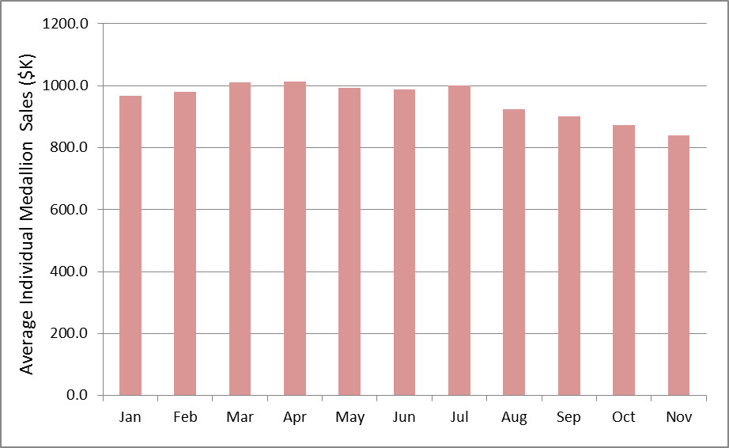

I also tried to characterize the fluctuations in these data and I used the population standard deviation of the 62 cases as a measure, which gave a reasonable estimation of approximately the price fluctuations at $55K. This number is well over 5 times larger than the $10K used by the commission and so it is easy to see how their rule of excluding from consideration any transaction that was $10K below the previous month’s average basically led to the conclusion that prices were flat. In effect, the commission’s asymmetric approach introduces a bias into their analysis that simply ignores the statistical data from August to November.

Why might the TLC indulge in such statistical black magic? Well obviously to protect their own interests; but what exactly are these? Let’s explore some of the possibilities.

**The commission is seeking to protect the livelihood of the taxi driver.** This seems an unlikely explanation as propping up the price of a medallion clearly helps the owner maintain his investment while only indirectly helping the driver to maintain his job. The [median salary for a taxi driver in New York](http://www1.salary.com/NY/New-York/Taxi-Driver-salary.html) is about $38K, which is a far cry from the having the capital needed to buy a medallion, so it is unlikely that there is a high percentage of owners/drivers in the market.

**The TLC is trying to maintain the regulated market in the face of the intrusion by Uber and Lyft.**  There is a segment of the population who believe that preventing Uber and Lyft entry to the marker would have two benefits. The first is that it would prevent the kind of [fare-wars that erode driver pay](http://www.businessinsider.com/uber-drivers-say-theyre-making-less-than-minimum-wage-2014-10) and would their protect salaries. The second is that Uber and Lyft are not as committed to [passenger safety](http://mashable.com/2014/04/29/uberx-passengers-risk/) as they should be. Both of these explanations also seem to be unlikely. Uber and Lyft have made huge inroads into the driver-for-hire markets in many US cities and with the tacit or explicit permission of the local governance and so the TLC would be going rogue. Second, there is no evidence that Uber or Lyft drivers commit felonies at any higher rate than yellow cab drivers. In this hyper-connected world, bristling with social media, it is actually in the best interest of Uber and Lyft to have trustworthy drivers. Also, some conventional taxi drivers must be law breakers else why have a [court ruling](http://www.nyc.gov/html/law/downloads/pdf/TLC%202nd%20Circuit%20Decision.pdf) upholding the commission’s authority to suspend licenses of drivers who break the law.

**The TLC is trying to maintain its own influence and position.** This is the likeliest explanation. Government bureaucracies trade in their own form of wealth and capital which is measured by the authority they wield and the favors that they curry from the industries they regulate. [GNYTA’s website](http://www.gnyta.org/about-us.html) suggests that their relationship with the TLC is a cozy one when they state

GNYTA was formed because its members shared a vision – a vision of a strong vibrant progressive taxi industry in New York that would partner with government to create the most dynamic, fuel efficient and accessible taxi industry in the world.

GNYTA’s goal is not to be an obstacle but an actual partner with the legitimate goals of government.

Of course it is in GNYTA’s interest to align itself with its regulators as long as the latter controls the number of medallions, thereby maintaining a barrier to entry for competition. It is a classic protectionism arrangement where government and big business are partners for each other’s benefit and the consumer is of secondary interest. This type of arrangement is sustainable only until an external force upsets the status quo. This is what seems to be happening with the rapid rise of Uber and Lyft and the cracks in the relationship between the TLC and GNYTA are starting to appear.

Reader replies fall nicely into three viewpoints, each representing . First there is the group who believe that Uber and Lyft are dangerous big businesses that are trying to drive the hard working entrepreneurs individual taxi drivers out of work. Second there is the group who believe that the medallion is a seal of quality that guarentees that the yellow taxi cab drivers won’t commit felonies. Third is the group that welcomes the competition that Uber and Lyft represent

People who want TLC’s quality check

* 1. Uber drivers commit felonies
     1. Uber may want to block this
     2. With social media how?
     3. Uber depends on
  2. How many yellow taxi drivers commit felonies?
     1. More likely that this is hidden from the public

1. People who want protectionism for taxi cab drivers
2. People who want competition in the market
3. Protect its authority and importance?
4. Medallions act as a barrier to entry
5. TLC in bed with GNYTA
6. TLC in bed with Uber

## The Simple Facts about Unemployment

Many of my friends and co-workers don’t understand my concern about employment in this country. The unemployment rate has, after all, fallen from a peak of 10% in October of 2009 to the current value of 5.8% in November of 2014 ([data from the Bureau of Labor Statistics](http://data.bls.gov/timeseries/LNS14000000)). So, as the argument goes, what’s my problem?

Well, as I try to point out, the unemployment rate really doesn’t tell the whole story. It is only one measure of the health of the labor market and not necessarily a good one. When there is a lot of economic growth, as in the eighties and nineties, the unemployment rate is a reasonable measure of the health of the work force. When the labor market is experiencing the type of new normal that the country is currently mired in it is a poor measure indeed.

The reason for this is that the unemployment rate measures the percentage of workers who are in the work force and are actively looking for jobs but unable to be employed to the total population in the work force. What the unemployment rate doesn’t measure is the size of the work force relative to the population of the country as a whole.

This definition of the unemployment rate appears in both textual and mathematical form in countless articles and texts dealing with employment and the labor market. So does the caveat about the work force participation. However, I don’t know of a single place that illustrates these distinctions in an easy to calculate, visual form and so I decided to supply one of my very own.

For the sake of this illustration, I am going to assume a static population, a snapshot if you will, and I am simply going to calculate percentages based on a visual representation of various components of the population. Also for simplicity, our population will be divided into four demographics: minors, college age, working age, and retired. The definitions for these four demographics are:

|  |  |
| --- | --- |
| Demographic | Definition |
| minors | The portion of the population too young to hold a job in the economy. |
| college age | The portion of the population that is old enough to hold a job but who may choose to opt out to attend higher education. |
| working age | The portion of the population that is past the age to attend higher education and is in its prime working years. |
| Retired | The portion of the population that is past the age where it is allowed to work. |

Obviously these demographics represent a gross simplification of the actual population. There are never as cleanly drawn lines in the real case as there are in this ideal case. But to illustrate the point, these are close enough to make a good model for the economy and an easy model to understand the labor market. I’ll talk a little more about the complications after the basic model has been developed.

Let’s start with the ideal world shown here

<insert ideal_population>

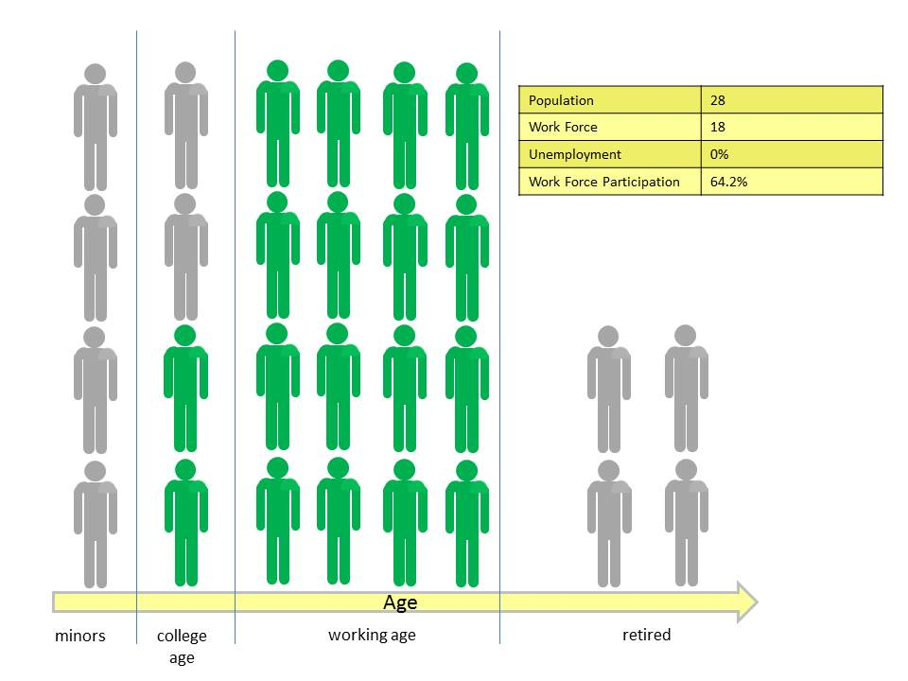

Those members of the population that hold jobs in the economy are colored green while those members who are not in the work force are in gray. It is worth taking a moment to talk about what is means to be in the work force. Clearly the minors and retired demographics are not in the work force because they are not allowed to hold a job. All the members of the working age demographic have a job and so they are obviously in the work force. The only group that requires some thought is the college age demographic. In this ideal world this demographic is exactly split in half with two members opting into the work force and two opting to pursue higher education. With 24 total members of the population and 18 workers in the work force the work force participation is 18/24*100 = 64.2%. The unemployment rate is zero since everyone in the work force is working.

Now let’s introduce some economic realism and assume that not everyone who is in the work force can actually find a job. This more realistic world looks like

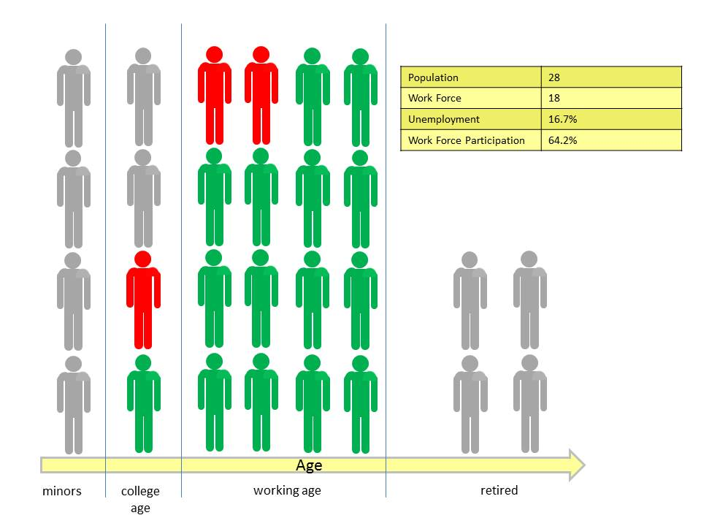

<insert some_unemployment>

where the members of our population who want a job but are unable to find one are now colored red. In this scenario, two workers from the working age demographic and one worker from the college age demographic are now out of a job. The number of workers in the work force has remained unchanged at 18 and so too has the work force participation but the unemployment rate, which is a measure of the percentage of the work force without a job, has risen from zero to 15/18*100 = 16.7%.

Finally imagine that the college age worker has decided enough is enough and he heads back to an institution of higher learning and that one of the unemployed working age guys decides to stay home and play video games all day long. These two members of the population have now exited the work force (colored gray with red trim to remind us that they were once in the work force), which shrinks from 18 to 16.

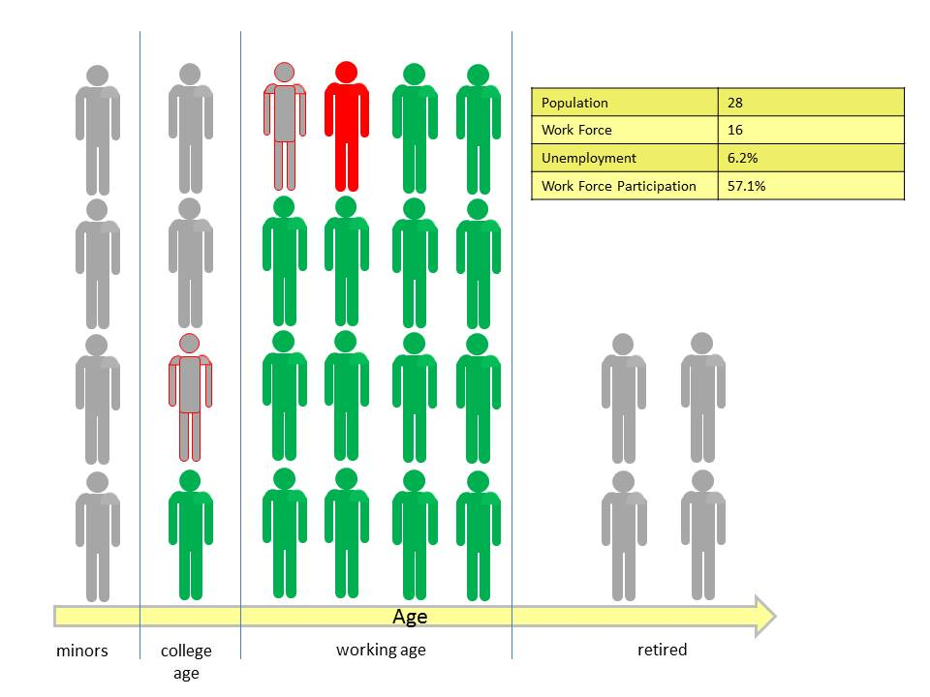

<insert shrinking_work_force>

The one remaining unemployed working age guy keeps at it but is still unable to find a job and the unemployment rate shrinks to 1/16*100 = 6.2%, reflecting only his frustration in not finding a job. The work force participation now falls to 16/28*100 = 57.1%.

Clearly the population as a whole is no better off with this lower unemployment rate than it was with the earlier case with high unemployment. In both cases, the number of employed workers in the population remains the same at 15. These 15 are now charged with producing the goods and services that will be consumed by all 28 members.

So does this model actually represent reality? The unfortunate answer is yes. While the unemployment rate has fallen so has the work force participation. Statistics pulled from the Bureau of Labor statistics for both the [unemployment](http://data.bls.gov/timeseries/LNS14000000) and [work force participation](http://data.bls.gov/timeseries/LNS11300000) rates result in

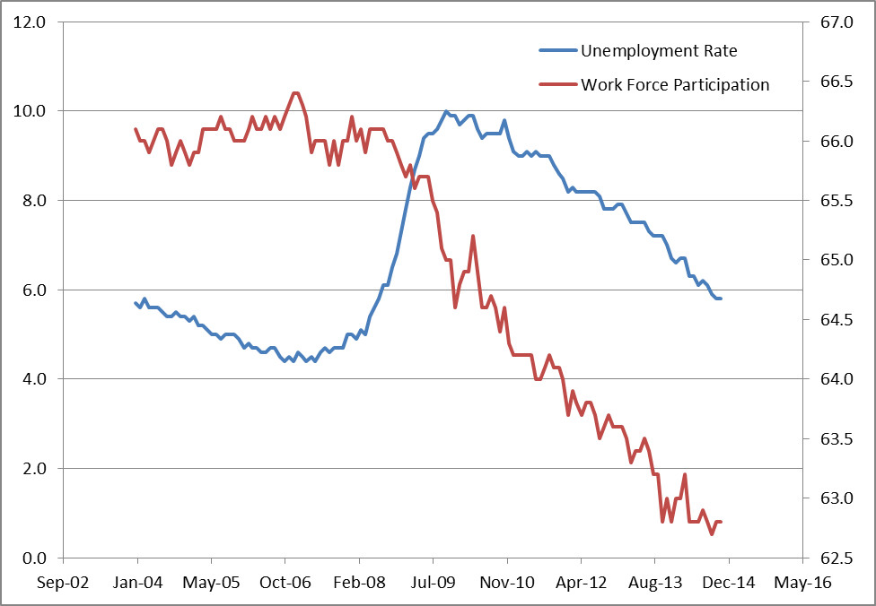

Of course the US population is not static like the model problem discussed above so maybe there is some way to reconcile a shrinking unemployment rate with a diminishing work force participation without having to conclude that there is trouble. Also what about all this news that says that hundreds of thousands of jobs have been created each month?

The population of the United States was [growing annually at about 0.7% in calendar 2013](http://www.huffingtonpost.com/2013/12/30/population-growth-rate_n_4520485.html), which is the lowest rate since the Great Depression. Assume a base population of 300 million, which is a lower bound well below the actual value of approximately 317 million. The number of new births each month in 2013 was 175,000. Now assume that somehow that this birth rate, in absolute terms, remained the same in perpetuity – that is to say that 2.1 million children would be born each year. This scenario is clearly unrealistic since the growth rate is measured relative to a growing population so to achieve this scenario we would have to have ever falling population growth rates. In fifty years of such a growth model, the population would increase from 300 million to 402.9 million with the growth rate decreasing from 0.70% to 0.52%. Note that this model also assumes that everyone lives to retirement. Finally assume that the country as a whole is content with a 62.5% work force participation rate.

None of these assumptions are realistic let alone likely, but by making them, we can calculate a lower limit on the number of new jobs needed each month just to keep the status quo. That number, of course, is 175,000 new jobs per month to match the birth rate. Now we can compare the actual job growth seen in the country over the time span from 2007 (the time when the country actually had about 300 million in it) to today against this 175K target.

Over this time, a net 2.835 million jobs were created according to the [BLS job creation numbers](http://data.bls.gov/timeseries/CES0000000001?output_view=net_1mth). That’s it! Barely enough jobs were created in 7 years to cover about 1 and 1/3 years of population growth in the anemic model discussed above and probably not even a full year under realistic population growth. In order to get back close to where we were in 2006, the last year where job growth approximately matched population growth, the country as whole would have to produce at least 14.7 million extra jobs in 2015. That’s over 1.2 million jobs a month – a far cry from the job growth currently hovering around 240,000 month on average for the first 11 months of 2014.

So the next time you hear news about the rosy picture of the US economy based on the unemployment rate take a moment, breathe, and think about all those poor souls wo have given up looking for a job.

## Free Electric Riders

In previous posts, I discussed the concept of the free rider and the harm that such a member of society can do to a common good. In this post, with a decidedly impish tone, I identify the growing number of free riders and the related villains that I will call cheap riders, how they are harming our road and highway infrastructure. And with a more serious air, I will suggest what can be done.

Who are these societal ne’er-do-wells? In what grimy back alley can we find them? How many of them are there and why aren’t the police cracking down? Well, we need go no further than our own neighborhoods. Look around your street or at your work. Find those among us who own and drive electric cars and you will find these despicable free riders. Seek out those of us with fuel-efficient hybrids and you’ve found the cheap riders who are also not contributing their fair share. Look for those of us that eschew car ownership completely but expect the advantages of mobile society and you’ll have discovered a different kind of rogue. Ranking the villainy of each of these groups is difficult as men of good conscience can agree to interpret the same facts differently. I judge the weight of their societal blight based on a combination of sheer numbers and on overall the snarkiness of their mindset.

Now before a group of traditional internal-combustion enthusiasts band together to form a flash mob that begins to tar and feather these more ecologically-minded (or in the case of the Tesla more futuristically-minded) of us consider that it isn’t their fault. To paraphrase Shakespeare’s *Julius Caesar* (Act 1, Scene 2), the fault dear reader lies not in our stars but in our poor understanding of economics.

The generally understood and designed way of supporting our roads was [constructed in the days of yore to be a per-gallon tax on gasoline or diesel](http://www.washingtonpost.com/opinions/robert-samuelson-three-myths-about-the-highway-trust-fund/2014/07/09/edb7c758-0770-11e4-a0dd-f2b22a257353_story.html). The idea here is that ‘those that drive on it will be those that pay for it’. A fine sentiment that may have made sense back in the day when June Cleaver and her immaculate dress and fine pearls roamed the Cleaver household cleaning and cooking but which now seems dated and stupid in these more enlightened days of electronic everything.

Consider first that marvel of modern engineering the Tesla. A fully electric car, the Tesla neither consumes a drop of gasoline nor does it emit a molecule of exhaust gas from the combustion of a fossil fuel. Stealthy and silent, you can’t hear it come upon you nor can you hear the damage it does to the roads upon which it travels. Nonetheless, its passage on the roads does do damage both in the physical and in the economical sense. The Tesla driver is able to take advantage of the roads without paying for their upkeep, effectively circumventing the ‘those that drive on it are those that pay for it’ maxim. And to heap insult on injury, many places, such as the progressively-minded University of Maryland, provide free parking and free charging to this scoff laws.

This guilt is equally born by those who have plunked down far less money to own a Leaf or a Volt or whatever other kind of electric car is out there. In all these cases, the tragedy of the commons is occurring before our very eyes and rather than scream in outrage we applaud their contribution to society.

Closely behind this no-emissions crowd, is the more sinister hybrid owner, who makes up in volume what he lacks in technology. Exemplified by the ubiquitous driver of the Toyota Prius, he seems to be, on the surface of it, a nice enough kind of guy. He drives to the same markets you do, you pass him on the road to work every day, and you both buy your gas at the same stations. It is his ability to blend in that tricks you into missing the inestimable harm he is causing to our roads. Found in far greater numbers than his all-electric brethren, he puts large number of road-bashing miles on our nation’s bridges and boulevards while paying a minimal amount of gasoline tax for the ‘privilege’.

Some numbers should help to put this dire situation into clearer focus. Take a side-by-side comparison between the Toyota Prius and the Ford Fiesta; both vehicles being similarly-sized offerings in the small car category. The Prius tips the scales with a curb weight of 3072 lbs compared with the Fiesta’s slightly lighter 2537 lbs. Assuming a 60-40 split between city and highway driving, the Prius’s effective gas mileage is 49.8 mpg compared with the Fiesta’s effective 35.8 mpg. The implication here is clear. The Prius delivers 20% more pounding to the road (3072/2537) than the Fiesta does while paying 40% less for the upkeep (49.8/35.8).

But no demographic is as sinister as the car-less. These people would pass themselves off as being above the fray – free from the mad obsession with driving from hither to thither. After all, why can’t people live where they can bike to work, or walk to the market. This holier-than-thou attitude blinds them the fact that all of their basic services and creature comforts come from the nation’s roads. How else does the organic food they eat make it to market? How do they products they consume, the electricity that they use, the medical services they pine for come to their locale without the infrastructure used by the driving crowd?

So the answer seems to me to be quite clear. All of us have a vested in interest in the common good that is the nation’s highways and byways. Just like public schooling or national defense or police and fire services, the roads are a common good that works for all and that should be paid for by all. The idea that ‘those that drive should be those that pay’ is ridiculous and should be met with as much scorn as is heaped upon those that say “I don’t have any children why should I pay for schools”.

## Gini in the Bottle

For many years the debate about income inequality has seemed to me to behave like some of my more primitive attempts at cooking. For a while it simmers, warranting almost no attention and sitting there like the proverbial watched pot with nothing happening. Then, as some political burner turns up the heat, it boils over into something messy like the Occupy movement, suddenly demanding damage control and cleanup. And much like my aborted attempts at food preparation neither of these situations ends up leading to anything satisfying.

As a result, my interest in the income inequality debate falls into the same place in my mind as does my interest in the culinary arts – a dusty corner where I vaguely recognize that people are passionate about it but where I reason that I’ve nothing to contribute to it and it has nothing to contribute to me. And so I basically tuned it out. This situation has thawed for me this past week (forgive what will be the last food analogy) with the publication of an intriguing nugget in an article from the Washington Post.

In this article, entitled [‘Income Inequality – the issue the Democrats want’](http://www.washingtonpost.com/blogs/post-partisan/wp/2015/01/05/the-insiders-income-inequality-the-issue-the-democrats-want/), Ed Rogers rails against what he paints as the Democrat hypocrisy. The point that Rogers tries to make is that the Democrats don’t want to address income inequality they simply want to use it a political tool to separate their message from the Republican one. He may be correct – I don’t know – but, just as I was going to stop reading at the end of the third paragraph, he posed the question ‘What exactly is “income inequality”?’ This grabbed my attention and I found out that income inequality is measured by something called a Gini Coefficient. Suddenly I was there was a possibility of real data and actual statistical analysis and I got excited. Rogers also cites as strong support for his contention an article in the New York Times entitled [Is Life Better in America’s Red States?](http://www.nytimes.com/2015/01/04/opinion/sunday/is-life-better-in-americas-red-states.html?ref=todayspaper&_r=2) In this article, by Richard Florida, presents a chart of Gini coefficients calculated by state that show that the majority of worst 21 states in terms of income inequality in 2012 are in blue or purple states compared with the majority being red in states in 1979. Suddenly there was actual tabulated data showing a before and after situation.

I then went off to try to understand the Gini Coefficient, which, in a nutshell, is based on something called a Lorenz Curve. Resolving to go only one more turtle down, I then set myself to understand the Lorenz curve. Fortunately a Lorenz curve is relatively easy to understand.

The whole machine starts with a table of income distributions. The simplest presentation I’ve found is from Timothy Taylor’s book [*Principle of Economics: Economics and the Economy, 2nd edition*](http://www.amazon.com/Principles-Economics-Economy-2nd/dp/1930789130/ref=sr_1_2?ie=UTF8&qid=1421198653&sr=8-2&keywords=timothy+taylor+economics). Start by dividing the existing population into quintiles and then measure the income that each quintile receives for a given year. For example , in the years 1967 (the first year measured in the US), 1985, and 2005, the income distribution looks like

|  |  |  |  |
| --- | --- | --- | --- |
|  | Percentage Income Distribution | | |
| Quintile | 1967 | 1985 | 2005 |
| 1st | 4.0 | 3.9 | 3.4 |
| 2nd | 10.8 | 9.8 | 8.6 |
| 3rd | 17.4 | 16.3 | 14.6 |
| 4th | 24.2 | 24.4 | 23.0 |
| 5th | 43.6 | 45.6 | 50.4 |

From the table one can tell that in 1967, the bottom 20 percent of the population received 4.0 percent of the income and that this percentage fell to 3.4 percent by the year 2005. Likewise, the middle 20 percent also saw a drop in their share of the income from 17.4 percent to 14.6 over the same time span.

The next step is to construct the cumulative income by partially summing down the column. The corresponding data looks like

|  |  |  |  |
| --- | --- | --- | --- |
|  | Cumulative Percentage of Income | | |
| Population Percentage | 1967 | 1985 | 2005 |
| 0 | 0 | 0 | 0 |
| 20 | 4.0 | 3.9 | 3.4 |
| 40 | 14.8 | 13.7 | 12.0 |
| 60 | 32.2 | 30 | 26.6 |
| 80 | 56.4 | 54.4 | 49.6 |
| 100 | 100 | 100 | 100 |

with the obvious boundary conditions that zero percent of the population receives zero percent of the income and 100 percent of the population receives 100 percent of the income. The addition of the 0-line will be needed in the next step. Note carefully how the value at say 40 percent of the population is the sum of the 1st and 2nd quintiles while the value at 60 is the sum of the first 3 quintiles. The graph of these values then gives the Lorenz Curve as shown below

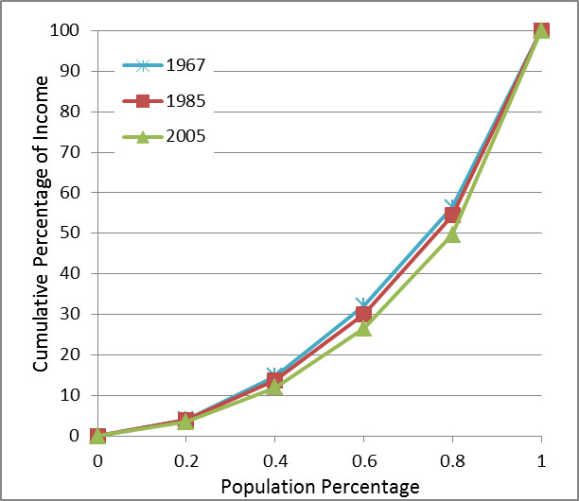

Calculation of the Gini Coefficient is a bit more involved and requires two new Lorenz curves and a modest amount of computation. The first curve, called hereafter the ‘perfect curve’ represents a perfectly balanced society with equal income distribution over all segments of its population. The resulting income distribution and cumulative percentage of income are

|  |  |  |  |  |
| --- | --- | --- | --- | --- |
|  | Percentage Income Distribution |  | Population Percentage | Cumulative Percentage of Income |
|  |
| Quintile | Perfect |  | 0 | 0 |
| 1st | 20 |  | 20 | 20 |
| 2nd | 20 |  | 40 | 40 |
| 3rd | 20 |  | 60 | 60 |
| 4th | 20 |  | 80 | 80 |
| 5th | 20 |  | 100 | 100 |

The second curve, called the ‘imperfect curve’ represents the income distribution of a completely unbalanced society with only one member receiving all of the income and every other member receiving nothing.

With all the ingredients now in place, the Gini Coefficient is then defined as the ratio of the area between the perfect curve and a given Lorenz curve to the area between the perfect and imperfect curves. As a formula, if A is the area between the perfect curve and a given Lorenz curve and B the area between a given Lorenz curve and the imperfect curve, then the Gini Coefficient, denoted as G, is given by G = A/(A+B). This is shown in the figure below with the Lorenz curve given for a linear distribution of income (first quintile has 6.7 percent; the second quintile has 13.3 percent, etc.).

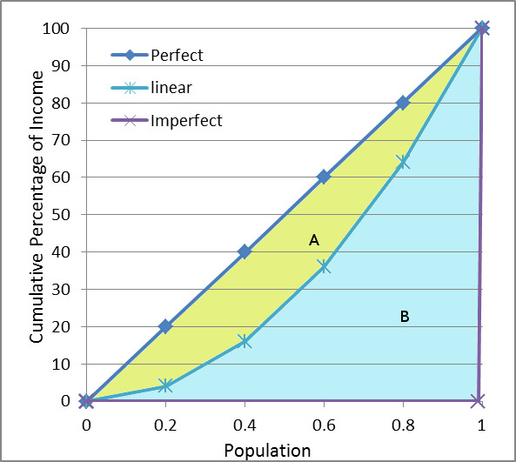

The area between the perfect curve and the given Lorenz curve is most easily calculated by calculating the area beneath the given Lorenz curve (B) and subtracting it from the total area beneath the perfect curve (A+B), since the latter has the known value of 0.5. The easiest way to see this fact is to convert the y-axis (cumulative percentage of income) to fractions by dividing by 100. The perfect curve is now a 45-degree diagonal in the unit square with the area of the triangle enclosed by it and the imperfect curve being one half. The resulting expression for the Gini Coefficient is then A/(A+B) = (A+B-B)/(A+B) = 1-2B.

So the computation of the Gini Coefficient comes down to computing the area B by integration. For a mathematically specified distribution, the functional form of the Lorenz curve is known and the area can be carried out using calculus. For example, the linear distribution curve results in the functional form of the Lorenz curve of x2, where x is the population fraction. Note that the linear curve when partially summed must be normalized thus its Lorenz curve is x2 not x2/2. The integral of x2 is x3/3, which when evaluated on the interval [0,1], gives B = 1/3 and G = 1-2B = 1-2/3 = 1/3.

For empirical distributions, such as listed above for the years 1967, 1985, and 2005, a numerical approximation to the area under the Lorenz curve can be estimated in a variety of ways. To illustrate, I chose the particularly simple approach of using the trapezoidal rule. The resulting Gini coefficients are then

|  |  |
| --- | --- |
| Year | Gini Coefficient |
| 1967 | 0.370 |
| 1985 | 0.392 |
| 2005 | 0.434 |

Clearly there is a growing trend towards greater income inequality but what to make of it?

First it is important to remember that the Gini Coefficient doesn’t measure poverty. Everyone in a population can be rich and the Gini Coefficient could indicate an income distribution far from the perfect curve (think of football players and owners). Likewise, everyone in a population can be poor and the Gini Coefficient could indicate an income distribution near the perfect curve (think of a native tribe in the Amazon like the Yanomama) .

Second, to quote Taylor:

No society should expect or desire complete equality of income at a given point in time, for a number of reasons. First, most workers receive relatively low earnings in their first few jobs, higher earnings as they reach middle age, and then lower earnings after retirement. Second, people’s preferences and desires differ. Some are willing to work long hours to have large income…Others will work fewer hours… Third, people can be lucky or unlucky.

Some decades ago, an economist named Henry Simmons tried to find an objective, scientific way to determine how much inequality was appropriate. After a great deal of thought, he decided that the question had no answer.

Okay, so it seems that income inequality is a fixture of life but is there any way to understand the observed trends. I will point out that trends in income inequality are cited by Taylor to be predominantly due to two effects.

The first is a demographic shift amongst the higher income earners in which they have be preferentially marrying each other (e.g., a lawyer with a lawyer) thereby concentrating more income in the top earners. This is to be contrasted with an older model in which a high income earner (e.g., a doctor) tended to marry a low income earner (e.g., a school teacher). I would argue that this change reflects an underlying improvement in American society and the upward mobility of women.

The second effect is as discouraging and the first is encouraging. There is an educational gap between the highly skilled worker and the low or unskilled component of society and it seems to be widening not shrinking. Highly skilled workers are in high demand due to the technological advances over the past 30 years and as more of them enter the market place the pace of technological development and the need for more advanced training increases. This problem is further exacerbated by the fact that lower income families not only have fewer good educational opportunities but they also tend, more often than their rich counterparts, to be [comprised of a single parent, which creates a substantial educational disadvantage](http://www.washingtonpost.com/blogs/wonkblog/wp/2014/12/18/the-unbelievable-rise-of-single-motherhood-in-america-over-the-last-50-years/).

## How Kodak Went So Wrong

One more than one occasion I’ve visited [Eastman House](http://www.eastmanhouse.org/) in Rochester NY. Situated in the south-east section of the city, the house which Kodak founder George Eastman built stands on a beautiful tree-lined street which is particularly delightful to visit in the fall. Entry to the house occurs in the side furthest from the road and the visitor finds himself passing through the International Museum of Photography and Film before coming to the house proper.

Exhibits of cameras and photographs, famous and unknown, fill the halls and line the walls of the museum, emphasizing and re-emphasizing the revolution that George Eastman’s innovations played in the development of the modern world. After all, Eastman’s products shaped society and helped birth such modern day fixtures as motion pictures, photo journalism, scientific imaging and the like. They also netted Eastman a vast fortune.

His house, which lies just beyond the museum, is a grand mansion in the true captain-of-industry style worthy of the money he earned in his lifetime. Eastman was so wealthy that he was actually able to have the house enlarged by having it cut down the middle, separating the pieces by several feet and then having the gap subsequently filled in and decorated. The first floor of the house is preserved essentially in the style and furnishings of its owner at the time of his death. On the second floor, however, some of the rooms were turned in multimedia exhibits where the visitor may learn more about the man and the vision that netted him his wealth.

[George Eastman](http://en.wikipedia.org/wiki/George_Eastman), was born in 1854 to what could be called an upper-middle class family. His father, George Washington Eastman, had started a business school in the early 1840s but the family fortunes took a steep downturn shortly after George’s birth when his father took ill. The family moved to Rochester in the 1860, just two years before the father’s death from a brain disorder.

George eventually left his schooling behind and went to work as a bank teller to raise money to support his mother and himself. Extremely dissatisfied with his experiences with professional photographers of the day, Eastman spent his spare time tinkering with the chemical processes underlying the capture of a photographic still. From 1880 to 1884, he successfully filed for 3 patents for new ways of applying photographic emulsions and the invention of photographic film. Four years later, he invented the first camera designed to use the film. Four years after that (1892) he founded Eastman Kodak company, which enabled him to earn vast sums of money, positively affect the lives of his employees and the people of Rochester, and to donate over 100 million dollars to various institutions of higher learning here in the United States and abroad. His invention of film earned him the Gold Medal of the American Institute of Chemists in 1930. He died of a self-inflicted wound two years later 1932.

It is easy to look on George Eastman’s life, his wealth and fame, his philanthropy and public works, and miss the one main ingredient that led to his success. It was the simple business idea that people would want to take photos for themselves. His innovations, especially [the Brownie](http://en.wikipedia.org/wiki/Brownie_(camera)), were means to the end of bringing photography out of the hands of the experts and putting into the hands of anybody with an enthusiasm for capturing an image, documenting a memory, or making a piece of art. That’s how George succeeded. And, unfortunately, it was the loss of that idea that led Kodak to fail.

When Eastman was at the helm, Kodak reflected his innovative spirit and his desire to put people first. The company was unafraid to try new things, such as a 13-month accounting year or a 40 hour work week, not because they wanted to be seen innovating nor because it was shiny and new, but because they cared about people.

After his death, Kodak began a strange trajectory in the business world. From the 1930s to the 1990s Kodak ruled the landscape of film photography, with the company [commanding 90% of film sales and 85% of camera sales as late as 1976](http://en.wikipedia.org/wiki/Eastman_Kodak#History). The constant revenue supply fueled a research development engine that generated many inventions. Some of the most notable are:

* Invention of the tunable dye laser (1970)
* Invention of the digital camera (1975)
* Development of the [Bayer filter](http://en.wikipedia.org/wiki/Bayer_filter) for digital color photos (1976)
* Launch of the first megapixel camera (1986)

Nonetheless, the same time frame saw a huge number of missteps. Kodak assumed that its [customer base would remain loyal under the encroachment of Fuji Film](http://en.wikipedia.org/wiki/Eastman_Kodak#Rivalry_with_Fujifilm) in the later 1970s and early 1980s. During the 1990s and early 2000s, the corporate motif was one of mergers and acquisition, and subsequent divestitures of same, sales of intellectual property, stock issues, seemingly endless branding and re-branding. All of this finally culminated with Kodak filing for Chapter 11 bankruptcy protection on January 19, 2012.

Having emerged from bankruptcy, [Kodak](http://www.kodak.com/ek/US/en/About_Kodak_Top/Our_Company.htm) now says that it:

has transformed itself into a technology company focused on imaging for business. Today's Kodak provides:

* + World-class R&D, based on Kodak's unique strengths in the materials, imaging and deposition sciences
  + Breakthrough products enabling customers to achieve transformational improvements in quality, productivity and sustainability
  + A broad solution set across graphic communications, product goods packaging, functional printing enabling
  + Software and professional services businesses use to redefine information flow and security

In an interesting take on Kodak’s bankruptcy, [*How Kodak Squandered Every Single Digital Opportunity It Had*](http://mashable.com/2012/01/20/kodak-digital-missteps/), Pete Pachal notes that

“But Kodak's inability to make any of its products stand out over the last decade is demonstrative of an overall reluctance to innovate. Certainly, if you asked Kodak executives in the early 2000s if they were committed to innovation, they would have answered yes, but real innovation requires risk and vision. You don't kill all Wi-Fi cameras just because the first model got a lukewarm response from the market — that is, if you really believe in the core idea.”

I think that Pachal is close to the mark in his criticism but that he misses the final point. It isn’t innovation that matters but a clear focus on ‘the what’ of your business not ‘the how’. Eastman clearly understood this distinction since his moves were always a means to an end. Development of film was the method to bring photography to everyone. The Kodak and Brownie cameras were not innovations for the sake of being committed to innovation but rather a service being provided by Eastman to people everywhere.

During the years between Eastman’s death and filing for Chapter 11, we saw a lot of bumbling and stumbling from a culture inculcated during Kodak’s dominance; a culture focused on *how* to do things not *what* to do. We saw research and development done for its own sake because that’s *how* a company stays on top. We saw companies being drawn into and spun off of the central cooperate structure because that’s *how* a powerful business operates. We saw a slavish devotion to film because that’s *how* Kodak made their money.

That’s why it wouldn’t have mattered if Kodak had stayed with WiFi for photosharing or if had embraced something else that was innovative. Rather if the company had stayed focused on the human element, they would have continued to grow digital photography and they would have invented WiFi, cloud computing technology and no doubt launched their own kind of Instagram. Not because it was how to succeed but because it was what people would have wanted. This Kodak would have known when to throw away old ideas in favor of new and would have stayed ahead of the curve because this Kodak would have thought just like the customers they serve.

As a result, I would argue that the new Kodak is in no better position to succeed than the old Kodak before it emerged from Chapter 11 protection. Not because the new Kodak has picked the wrong core competencies or is focused on the wrong market segment but because the new Kodak shows no indications that it is focused on service. It may stay in business but it will never thrive again until the company is run by people with a vision like George Eastman; people who now what the customer wants.

George Eastman would be disappointed

## Regular Maintenance

See if you recognize this typical scene, played out from time-to-time, in workplaces all around the country. One of your co-workers is late coming to work. Upon his arrival, he meets the office’s quizzical looks with a verbal response that amounts to something like “Yeah! My car had problems this morning. I think I need a new…”. I am willing to bet that most everyone has been on both the giving and receiving end of this exchange.

The next segment in the exchange goes something like this. Everyone gathers around and discusses the problem. Opinions fly as to what is exactly wrong, how much to pay, where the best place to go to get the repairs done, and how to make sure that the mechanic doesn’t cheat. Typically, there is a lot of varying ideas about the specifics. “Take it to the dealer”, says one. “No! don’t go to the dealer. I know a guy.”, responds another. “Check the internet first”, comes yet another bit of advice, and so on. But there are really no differences in the general goal. Everyone involved is trying to find the best value, the best repair relative to the price. And every one of them is engaged and has knowledge that can be put to use.

Let’s be specific and consider the case where you need a new set of brakes for your Honda Civic. A simple internet search with the search string ‘new brakes cost honda civic’ returns as one of the top hits a link to [Civic Forums](http://www.civicforums.com/forums/43-wheels-tires-brakes/149893-how-much-you-pay-new-brakes.html), where the same type of dialog happens in the medium of the chat forum. For this particular repair, the generally agreed upon estimate of the cost is $150.

Also note that no one suggests that the owner file a claim with their car insurance. No one even entertains the notion since replacing the brakes is part of the regular maintenance on a car. Everyone recognizes that car insurance is meant to hedge the risk of an accident that damages life, limb, and property. Most people go through life hoping that they never have to draw on their car insurance policy.

Now consider another type of regular maintenance – maintenance of the human body. The comparison between this activity and the situation with the above is quite stark in the differences.

To begin, our natural shyness about the body tends to dissuade us from talking about the standard types of treatments we all need. Few have the same enthusiasm for discussing trips to the doctor with their co-workers as they do trips to their mechanics. But wait, you say, here is where the internet comes into play. A person can set up an avatar, assume a cyber-identity, and maintain his personal dignity while get answers to some of the more delicate questions that can be posed. And this is absolutely true. One need only surf the World Wide Web for a while to see that people are quite willing to discuss (and display) just about any matter concerning their body with the mask of anonymity that a computer account affords.

So then, why is there so very little general knowledge about how much various medical treatments will cost? And what questions should be asked? And so on. As a society, we know far more about how to be informed and savvy consumers is almost every other market that is out there and yet we are total dunces when it comes to the medical markets.

Again to be concrete, let’s look at a specific medical maintenance issue. Suppose you’ve now of the age where your doctor wants you to get a regular colonoscopy. Where do you go? How much should you pay? How good is the doctor and how much risk is involved? All of these are valid questions but I am willing to bet that very few know meaningful answers. Let’s take a look at the first two questions in detail.

A simple internet search with the search string ‘colonoscopy cost’ returns as one of the top hits an article in *The Health Care Blog* entitled [‘How Much is My Colonoscopy Going to Cost? $600? $5400?’](http://thehealthcareblog.com/blog/2014/08/27/how-much-is-my-colonoscopy-going-to-cost/comment-page-1/) by Jeanne Pinder. As the title suggests, there is a vast range in the costs of a colonoscopy ranging, according their research, from $600 to $5400, a factor increase of 9 from the lowest value to the highest value.

Pinder lists six items in the total cost that should be examined before committing to the procedure. These are:

* Doctor’s fee
* Anesthesiology cost
* Lab Tests
* Facility Fees
* Pre-procedure consultation
* Preparatory costs, including medications required for the procedure

However, Pinder points out that it is difficult to get straight answers for most of these items. The doctor, anesthesiologist, lab and facility all bill separately. All play the shell game between listing the charged price and the paid price. The charged price seems to be the cost that these service-providers initially ask while the paid price is what they settle on once the haggling with the insurance company is completed. Having so many moving parts also makes it easy for each group to avoid accountability and, indeed, their usual response, as cited in the article, is “we don’t quote prices in advance.” Imagine going to your mechanic and being told something to the effect “we’ll let you know how much it costs when we figure it out” – you would never put up with it.

Recently I discussed the stark contrast between regular maintenance for a car and for a boy with a co-worker. He raised the objection “do you really want to have a procedure performed by the lowest bidder?’ On the surface this may seem like a cogent argument but some reflection shows that it is inadequate.

What logical connection is there between paying more and getting better health care? There is some truth in the old maxim “you get what you pay for” but that really only applies to situations where the consumer is trying get a ‘sweet deal’ by cutting corners. This maxim is utterly devoid of meaning when the consumer knows next to nothing about the goods or services he’s buying. Perhaps a doctor who charges more for his services may be worth it. One the other hand, he may be a shady character who talks a good game, gives poor or even dangerous service, and is putting his profits before the patient’s needs. He may have to charge high prices to cover his malpractice claims and you just don’t know it. It is also possible that a good doctor is one who possesses enough skill that he can diagnose your problem without groping through unnecessary and costly tests which consume your time and put you through needless pain (both physically and mentally).

There is a related objection that asks why would you want to skimp when it come to your health. This objection is also patently fallacious. My health depends intimately on a day-to-day basis on the condition of my brakes and tires but that doesn’t stop me from seeking the best price. By seeking the best price, I am actually conserving my resources for other things that also have a positive impact on my health, like going to the gym, or buying better food, or moving to a better neighborhood. The word ‘skimp’ is merely a red herring that is meant to stop us from realizing that purchasing medical services is done, like every other purchase in life, in a market.

The short of it is that when it comes to car, home, or appliance maintenance, each of us is reasonably knowledgeable in the marketplace. Each of us tries to find the best value and each of us understands what insurance covers and why. In the medical market, few if any of us have enough knowledge or enough courage to seek the best value and to understand what the role of insurance should be. We trust that doctors and hospital and medical practitioners will protect our interests in a way that we don’t trust mechanics. But this trust is predicated on nothing more than the fairy tales we’ve been told on television and in the movies. Until each of us takes responsibility for being informed health consumers the system will remain in critical condition.

## Turning an Old Saying on its Head

***Time is money.*** From our earliest years to the twilight of our lives, each of us hears that sentence over and over again. It slides across the page in print and pounds our ears in radio, film, and television. It’s usually uttered by some ruthless wolf of Wall Street or miserly business man with no heart. It’s a cruel phrase that weighs profit in one hand and people in the other and finds the human side of the equation wanting. It’s the proverbial [elephant in the room](http://en.wikipedia.org/wiki/Elephant_in_the_room) that we fervently wish to be false but fear is true – that the almighty dollar rules our life, exactly as we are warned in that classic song by the O’Jays.

<iframe width="420" height="315" src="https://www.youtube.com/embed/Ll3uipTO-4A" frameborder="0" allowfullscreen></iframe>

But how many of us really understand what that ***time is money*** is all about? Is money really the evil necessity that prevailing wisdom warns us about? How might our attitude towards money be different if we simply turned that old trope around to read: ***Money is time***?

Let’s take a moment to review what money really is by looking at its origin. It’s common knowledge that, prior to the invention of currency, bartering was the only way of trading goods and services. We’ve all learned that it school (at least we should of) and there is that Schoolhouse Rock song

<iframe width="420" height="315" src="https://www.youtube.com/embed/J7hNOt2Y0J8" frameborder="0" allowfullscreen></iframe>

that tries to explain how money arose from the bartering system. The song is catchy but its message is muddled. Money wasn’t invented to make it easier to carry goods around or to make change. It was invented to save the most precious commodity a human has: his time.

Living with currency of all sorts (paper and electronic) makes it easy to ignore just how time consuming barter must have been. A typical scenario might have looked just like this. Let’s suppose that Charlie lives in an agrarian society where there is division of labor but no currency. Charlie raises chickens and since he can concentrate on their breeding and rearing, he can produce far more chickens in a unit of time than he could if he didn’t specialize. Having more chickens than he needs he is willing to trade some of his for sheep that his neighbor Steve breeds. He is also willing to trade with Pam for some of her pigs or William for some of his wood but not with Fran or Harry since Charlie dislikes fish and has no use for hay.

Problems arise when Charlie wants pigs but Pam is unwilling to trade because she wants hay. Unfortunately, Harry won’t trade with her because he wants sheep. Steve, however, doesn’t want hay because he needs wood to fix his house. Steve’s willing to trade with William has his mind on the nice fish tacos he could make if only he had some fish. Fran won’t trade with William, even after William has offered his finest oak lumber because Fran is dreaming of a nice chicken sandwich but is lacking the main ingredient. By visiting each in turn, Charlie is able to piece together a plan of action proceeds to make four transactions that he doesn’t want to make to finally arrive at the one he does. First he trades chicken to Fran in return for fish. Next he takes the newly acquired fish and gives them to William in exchange for some nice wood. And so on. The figure below shows the whole wacky scheme.

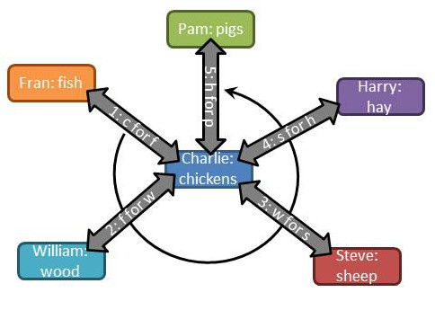

Charlie not only has to spend his time moving goods around this vicious circle but he also needs to spend time learning enough about all the other goods that he knows the worth of his chickens relative to all the other goods in his economy. Failure to know what his chickens are worth will prevent him from bringing home the bacon and cause them to come home to roost.

Many of us don’t relate to farming unless we are playing Harvest Moon or Farmville. Fortunately for us, this idea of horse trading from A to B to C and so on is kept alive in sitcoms. My fondest memory of this is the episode of M*A*S*H entitled ‘For Want of a Boot’ in which Hawkeye tries to get a new boot by making a chain of transactions. Of course it blows up in his face just as he’s about to achieve his goal as last person reneges, setting off a chain reaction that sets him back at square one with only a long useless day to show for his efforts.

Obviously the situation would be greatly improved if there were a central entity with whom everyone could transact business and who also knew the relative worth of each person’s goods. Fortunately for our little farming village, money is such an entity.

The invention of currency allows for a single transaction between each seller and a buyer saving a lot of time. The market where the money and goods are exchanged provides the framework for determining the relative worth of each good.

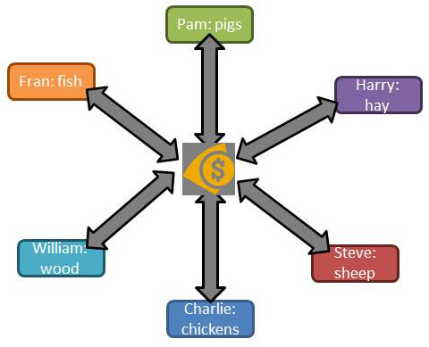

The adoption of currency also allows our little group to preserve the worth of their goods in a non-perishable form. Fish may spoil and wood may rot. The chickens may die and the sheep grow old. The hay may get moldy and the pigs may get skinny. But the value of the good is secure once it is traded for currency. Money also allows for the expansion or contraction of the economy when a new member arrives (Tim making tools) or an existing member leaves (Steve goes to greener pastures).

To summarize these benefits, we say that money:

1. Acts as a medium of exchange
2. Sets relative worth via the prices paid for each good
3. Holds the value for future use.

In all of these cases, the aim is provide more time for everyone involved to live life and enjoy. So the next time you see ‘Time is Money’ and you cringe, turn that expression on its head and remind yourself that Money is time and that it is time that really counts.

## What Does the Fed Do Now?

Well the January jobs reports are in and the economy created a reported [257 thousand jobs in January](http://data.bls.gov/timeseries/CES0000000001?output_view=net_1mth). Hurray for the US economy! This comes hard on the heels of job growth numbers for the [November and December of 423 and 329 thousand](http://data.bls.gov/timeseries/CES0000000001?output_view=net_1mth), respectively. The news is certainly welcome and the trend is encouraging but not all of the results are likely pleasing to either the current administration or the American public at large.

The fly in this particular batch of ointment is that the unemployment number has ticked up one tenth of one percent. Of course this is to be expected. As I discussed in an earlier post, when consuming the job statistics one has to make a sharp distinction between the unemployment rate and the workforce participation rate. Some of the folk who had dropped out of the work force entirely are now, no doubt, coming back in as job openings become available.

Indeed, Bloomberg’s lead article on the January numbers, entitled [*Jobs Report Crushes It*](http://www.bloomberg.com/news/articles/2015-02-06/payrolls-in-u-s-increase-more-than-forecast-along-with-wages)**,** agrees with this idea saying that

A 257,000 January increase in employment capped the biggest three-month advance in 17 years and delivered the strongest wage gain since 2008, figures from the Labor Department showed Friday in Washington. The unemployment rate rose to 5.7 percent from 5.6 percent as the prospect of finding work lured hundreds of thousands into the labor force.

The article goes on to say that

Gains in purchases can trigger a virtuous circle of hiring and spending that will probably assure Federal Reserve policy makers that the expansion can withstand an increase in interest rates later this year.

And there is the rub. The American people, by and large, do not understand the distinction between good and bad rises in the unemployment rate. The public’s inability to make these distinctions is mostly due to the low economic literacy and discourse of many of the institutions that proclaim themselves as the guardians of the working man. Primary amongst these are the media, who gush and dance in sound bite and spin, about any ‘favorable’ movement in an indicator whether or not it is actually good. Also culpable are the schools, which employ teachers less economically literate than my butcher. After all public school teachers don’t have to worry about producing a product the public wants since the government will make sure the bills get paid and the lights stay on no matter how many students show up. My butcher on the other hand needs to show just where the beef is.

So the public is likely to get restless as the unemployment rate rises. As public sentiment goes so goes the administration, which will likely leverage political pressure of the Federal Reserve to lower unemployment.

For those who don’t know, the Federal Reserve (or the Fed it is affectionately known by everyone – even them) is charged with control the monetary policy of the United States. As the nation’s central bank, it has only three arrows in its quiver:

* ***Open Market Operations*** – buying or selling of bonds to basically create or delete money from the economy. Buying bonds will increase the money available in the economy and selling decreases it.
* ***Reserve Requirements*** – sets the percentage of deposits that a bank must hold in reserve. Lowering the reserve requirement frees up more money to be loaned and raising the reserves limits the amount.
* ***Discount Rate*** – fixes the interest of a loan from the Fed to a bank.

The effect of each of these is to raise or lower the interest rate that banks charge each other for bank-to-bank loans (federal funds rate), which then trickles down to the end consumer as the rate to borrow. These three arrows are shot at two distinct targets with the intent of keeping inflation fairly constant at about 2% per year and keeping unemployment also fairly constant at about 5% per year.

The Fed has even gone to the trouble of creating a [web-based video game](http://sffed-education.org/chairman/) in which the player can pretend to be the Fed Chairman. The rules of the game are succinctly summarized when you are appointed chairman and are now in charge.

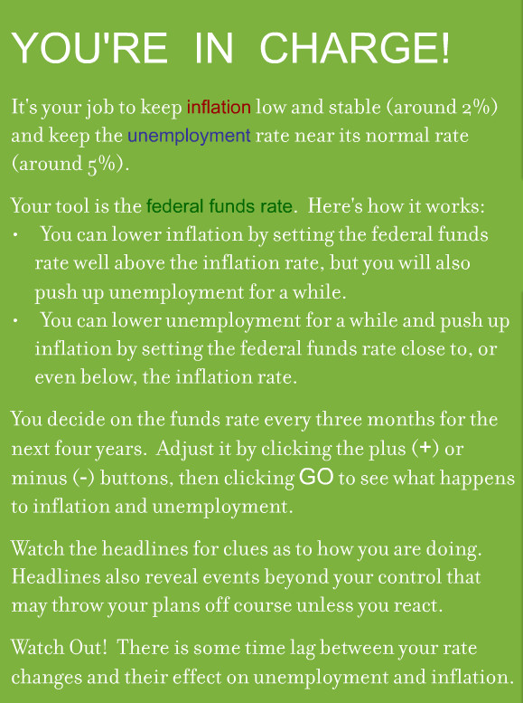

The simulation, while visually appealing, is primitive its fidelity and doesn’t inform the player what model is used to determine how the simulated economy will respond to the changes he makes. But considering that this is meant to be an educational tool my guess is that the rules are really simplistic. The following snap shows one of my attempts at managing the economy.

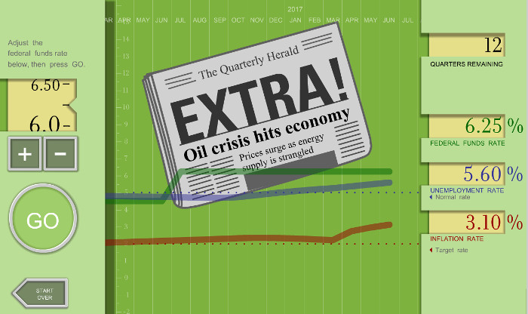

I suppose the Fed’s intent is to make it clear how hard it is to do their job and, perhaps, have us show a little gratitude for their steering an ocean liner successfully through troubled waters.

And maybe I should be grateful but I can’t help think that the Fed can’t possibly do a credible job of controlling inflation and unemployment by essentially adjusting the federal funds rate. This particular jobs report is a perfect case in point. One of the rules of the game states that ‘you can lower unemployment for a while and push up inflation by setting the federal funds rate close to, or even below, the inflation rate.’ That rule can only be true if something else, say the work force participation rate, remains constant.

In this particular case, keeping the federal funds rate low, as it currently is, is actually raising the unemployment rate and that is a good thing. Capable people who had fled the workforce need to come back in and swell the ranks, even if they are just looking for jobs at this point. It also isn’t a given that inflation needs to rise as these workers find jobs and begin to gather paychecks. That point of view only makes sense if one only assumes that the output of goods and services remains low so that ‘more money is chasing few goods’. But the recent decline in gasoline prices that has pushed inflation down (at least in practical if not statistical terms) is due to the industry of workers flooding into the energy sector.

So what does the Fed do? I suspect that they will coax the federal funds rate to rise and that, in the process, they will smother what is a good thing. I mean what else can they do when they are trying to achieve fine control using the crudest of tools?

**An Ultimatum You Can’t Refuse**

What do the terms ‘greedy capitalist’ and [*homo economicus*](http://en.wikipedia.org/wiki/Homo_economicus) have in common? Both terms are used, albeit with different connotations and by different groups, to describe a member of a society who pursues his own rational self-interest, trying to maximize it with each decision made. But what is rational self-interest? How do you define it? What is being maximized? And is the pursuit of one’s own self-interest necessarily incompatible with being a good neighbor? At the crux of these questions is the definition of rational self-interest.

Traditional economic analysis tends to view self-interest solely within the material context. Much like playing a board game, the success that you have had in maximizing your personal self-interest is completely judged by the amount of stuff you’ve accumulated. Cars, houses, jewelry, and money are all victory points that allow a person to rank themselves. You can declare yourself to have arrived at the good life when your house is bigger, your car more expensive, your jewelry more gaudy, and your bank account larger than the Joneses down the street. In this view, a rational person never fails to make a decision that increases his material wealth. This then is the definition of *homo economicus* – an individual who tries to maximize his utility when he is a consumer and his profit when he is a producer. You can go one step further in this description if you believe that the wealth one person enjoys is often or always at the expense of another. In this case, you would characterize a person pursuing his self-interest as a ‘greedy capitalist’.

But is this really how people act? It is true that we can find excellent examples of miserly, parsimonious, and bitter old men in literature. Scrooge in Dickens’ *A Christmas Carol* and Old Man Potter in Frank Capra’s *It’s a Wonderful Life* come immediately to mind. And certainly there are people who take materialism too far but does that mean that the system as a whole is corrupt or corrupting? I think not.

There is a fascinating game, in the sense of game theory, that is often used to determine the degree to which people will tend to maximize their utility by following their own rational self-interest. It’s called the [Ultimatum Game](http://www.fte.org/teacher-resources/lesson-plans/is-capitalism-good-for-the-poor/the-ultimatum-game/).

It works essentially like this. The game begins when the game administrator (shown in blue below) approaches two random people with a pile of cash and invites them to play.

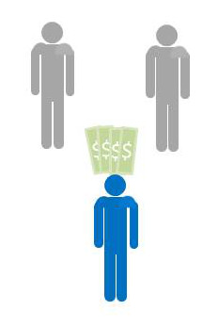

The rules are simple. The administrator will randomly designate one of them as the proposer and the other as the responder. The administrator will give the proposer the money and the proposer will decide on a split between himself and the responder. The responder’s only move is to decide to accept the proposal or reject it. If the responder accepts the proposal, they both get to keep the money in the proportions defined by the proposer. If the responder rejects the proposal he and the proposer walk away empty handed. The administrator emphasizes that the proposer gets only one chance to make an offer – there are no negotiations – and that this is the only time they will be playing this game.

Assuming that both players are *homo economicus*, the results of the game are easy to predict. The proposer should keep most of the money for himself and give only a small percentage, nearly zero, to the responder, because the proposer realizes that the responder will rationally maximize his own utility and will take any money offered. This way the responder will leave with more money than he had before the game began. The responder may lament the fact that the mere luck of the draw separates him from the proposer but money is money and free money is free money and so he accepts.

When this game is run experimentally, the results are quite different. The responder accepts the split only when it is close to 50-50 and often rejects when the offer strays to far from an equal split. Furthermore, the proposer, without having the benefit of playing this game before, often offers a split close to the 50-50. Why do both participants often behave unlike *homo economicus*?

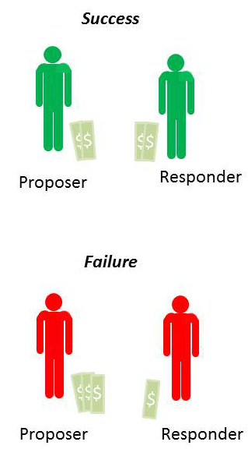

In practice, the experiment is done with more care and in a double blind fashion, as explained by the [Foundation for Teaching Economics’ lesson plan found here](http://www.fte.org/teacher-resources/lesson-plans/is-capitalism-good-for-the-poor/the-ultimatum-game/). But the results remain the same.

* The mean split is 60-40 (proposer gets 60% and the responder 40%)
* Most common split is 50-50
* About 20% of the offers that fall outside the ‘fair’ range are rejected.

How does one explain the proposer’s is generosity? How does one understand why responder ‘cuts off his nose to spite his face’ when the split is too low? As discussed in great detail in the [accompanying appendix to the lesson plan](http://www.fte.org/teacher-resources/lesson-plans/is-capitalism-good-for-the-poor/the-ultimatum-game-appendix-1), this game has been applied in a variety of circumstances where variations in age, gender, background and other factors have been examined and controlled. There appears to be no confounding variable that allows the administrator/experimenter to pre-determine when the participants will behave like *homo economicus*. Even the amount of money has been varied. Relatively vast amounts were brought to the developing world, where people subsist on only a few dollars a day, and the results remained the same.

A much more cogent explanation is that the definition of rational self-interest needs to be expanded from the materialistic realm to consider things like reputation, human compassion and altruism, and wisdom. And that these traits act to balance the purely materialistic instincts.

Virtue in the ancient world was defined not by a super-abundance of a trait but rather as the correct amount or a balance. A warrior who acted reckless and drove into battle with an overly great amount of physical courage was no more lauded than the coward who sat in the corner timidly, wanting for danger to pass by. The correct balance between caution and courage was the virtuous position.

Here in the ultimatum game, I see reflections of these ideas of virtue. The game results provide ample evidence that a human being engaged in a free market does not necessarily become selfish. The free exchange of goods and services is not inherently corrupting to those participate and they are no more likely to be preoccupied strictly with material possessions than if they had not engaged. The free market, like any tool, can be misused and can create an injustice, but it is not intrinsically flawed.

Lord Acton is famously quoted as saying “All power tends to corrupt; absolutely power corrupts absolutely”. I wonder what he would say about the Ultimatum Game. I’m not sure, but I like to believe that he would recognize the free market place as a place where people can come together to trade without the threat of coercion.

## What is Capital?

Most people have a fixed idea about the meaning of the word ‘capital’. They tend to think of it strictly in materialistic terms as money or goods that allow a business owner to produce products and earn a profit. A factory filled with machines or a bank brimming with money to loan comes to mind. Of course, there is nothing wrong with that definition as far as it goes – it simply doesn’t go far enough.

The word [‘capital’ is defined variously by Webster’s dictionary](http://www.merriam-webster.com/dictionary/capital) (3rd definition) as:

1. A stock of accumulated goods
2. accumulated goods devoted to the production of other goods
3. accumulated possessions calculated to bring in income
4. net worth
5. advantage or gain
6. a store of useful assets or gain

The general theme knitting all these definitions together being that capital is a set of assets or advantages (things of net worth) that promote the accumulation of other assets or advantages of the same or different kinds. So the commonly held view of capital is correct but limiting.

Why does it matter how capital is defined? It matters because as a society we continuously craft political structures and laws that limit what can be done with one type of capital while allowing other types of capital unfettered reign. We are also in a better position to understand the motivations and the accompanying behavior of others if we can perceive what market place they are actually engaged in and what capital they are trying to accumulate.

In the rest of this post, I am going to explore the two most common types of hidden capital: reputation capital and political capital.

### Reputation Capital

How familiar is the following scene? The latest sports news comes on the radio or television and the announcer coolly states that so and so has just signed with some such team for millions of dollars, making him the highest paid player at his position. A friend of yours turns to you and says “how much money does one man need?” Another friend responds by saying something like “It’s not about the money! He just wants more than the other guys. He just wants to be known as the best player in world.” What the player in question is doing is building reputation capital.

Alex Rodriguez is a prime example of this. His early success as a baseball player garnered him a reputation as a great ball player. That reputation, in turn, garnered him a chance to play in bigger venues, which in turn grew his reputation. The money was a secondary affair as his fame was really the means to the end. It opened doors for him, the entire country talked about his contract, his life style and his legacy.

This is all innocent enough, and A-Rod’s celebrity fame and eventual infamy did not actually shape the economic or political sphere very much. Outside of his influence on America’s pastime and popular culture, his mark will soon disappear.

Much more interesting and worthy of a skeptical eye are the so-called ‘paragons’ of society in whom is invested a lot of trust. Journalists and scientists fall squarely into these categories.

Take the recent fall from grace of NBC’s pride and joy, Brian Williams. Whether you call his fabrications exaggerations or outright lies, it is clear that he has played fast and loose with the truth. But why did he do it? I think his behavior is best explained by the model that he was trying to build his reputation as a gritty journalist. His fantasies related to his time in Iraq or his encounters with dead corpses and arm gun men in New Orleans in the aftermath of Hurricane Katrina were meant to build capital with his viewers. His intended his audience to regard him as an objective journalist who would back down before nothing and no one. From such a position, he wielded great power and basked in the adoration of fans and the admiration of his colleagues. He achieved assets and advantages that mere money could not buy.

University professors and academics engage in their own unique marketplace. They are first and foremost tradesmen whose primary focus is to sell their ideas to each other and to society as a whole. Journal articles, published books, and television and radio appearances are their currency and their academic reputations are their capital. Their wealth is measured in terms of the number of times their article is cited by peers or how many of copies of their book were sold or how many tweets and postings their TV appearance generated. As their reputation grows, so does their power, even though very little in the way of money changes hands.

### Political Capital

No matter where you work or volunteer, there are always a few people who are at the center of the institution. These are the people who get things done by pulling strings, facilitating compromises, and horse trading between one group and another. These people engage in the marketplace of political capital and the favors they give and receive are the currency. They hold and wield power in the institution and the larger the institution the greater the power; political capitalists in governmental positions being the most influential.

Political capitalists in government fall into two classes depending on whether they are elected or appointed and in the public eye (e.g. John Boehner or Samuel Alito) or they are far removed from general scrutiny (e.g. the head of the EPA). In both cases, even though their assets and advantages are never translated into a monetary value but these people are able to buy and sell for goods and services just the same. The public only thinks about this marketplace when an elected official grossly abuses their capital, as in the case of Bob McDonald, who was recently convicted of corruption for ‘selling access’ for his political capital in exchange for financial compensation. In other words, the public doesn’t seem to care when the bartering is done strictly in terms of political favors – even though such bartering may lead to material gain on all sides – but only seems sensitized when political capital is turned into cash directly.

### Regulating Marketplaces

As I alluded to above, the major reason to care about how capital is defined is to level the playing field when it comes to how different types of capital are accumulated, spent, or exchanged. As a society, we tend to regulate and focus on financial or monetary capital and ignore reputation and political capital.

I’m not objecting to the capitalists that trade in either of these marketplaces nor am I objecting to their accumulation of assets and advantages. I do object to the thoughtless position that fears the business man and his accumulated financial wealth but embraces the celebrity and his dominating reputation. I’m against laws that limit the modes of speech and the exchanges of ideas because they purchased by money but leaves unfettered the speech and exchange of ideas that are bought through political favoritism. I don’t understand why society is willing to suspicious of one and not the others.

I’m skeptical across the board. The accumulation of capital is not a bad thing, in and of itself, and I am willing to give the person who was acquired any type of capital the benefit of the doubt that he has earned it. But the use of that capital is no less corrupting if it is based on reputation or political connections than if it is based on cold hard cash.

# Gutless and Gun Runners

Suppose I told you about a man who both favored gun control, pushing through legislation banning firearms, and who was arrested for gun running? Would you conclude that the man was unstable and irrational? Or maybe that he was simply a hypocrite? After all, how to unite this two opposing positions? Well Leland Yee is just such a man and, if you give me just a bit more of your time, I think I can convince you that he is an excellent example of how opposing viewpoints can rationally unite around a common goal.

Our common ideas suggest to us that two opposites can never meet. Hot and cold don’t exist together any more than light and dark do. As kids in school, our teachers presented the idea of the number line with numbers greater than zero to the right and those less than zero to the left. Upon this construction, many of us would rank opposites at extreme ends of a line – for every positive there is a negative. Thermometers are designed this way and we tend to think about every other situation with ideas in opposition in the same manner.

The most familiar notion of ‘opposites’, which we see daily within the political discussion that surrounds us, is the use of phrases like ‘right’ and ‘left’ to describe supposedly politically opposite points of view. The idea being that the ‘far right’ and the ‘far left’ have nothing in common from a political perspective. But this notion is quite wrong and it is a fairly usual occurrence that ‘right’ meets ‘left’ on matters of regulatory policy. The conceptual model is no longer a straight line stretching indefinitely in opposite directions but more like a circle wrapping back to close on itself.

To see how ‘right’ can join ‘left’ in matters of regulation, consider the situation of those both for and against the use of alcohol during the age of [Prohibition](http://en.wikipedia.org/wiki/Prohibition_in_the_United_States). From the years 1920 to 1933, the United States made it illegal for anyone to produce or import, store, transport, or sale alcoholic beverages. These restrictions, codified into the Constitution through the 18th Amendment, were championed by a variety of religious and social welfare groups. The American Temperance Society, the Anti-Saloon League, and the Women’s Christian Temperance Union were notable in their push for this amendment. There was even a political party, called the Prohibition Party, which ran on a platform advocating abstinence from spirits; (curiously it still exists to this day). Collectively, these voices were known as the ‘drys’.

The idea these ‘dry’ groups had was that the use of strong alcohol spirits rotted the moral fabric of society. Numerous problems were laid at the feet of alcohol consumption, including prostitution, domestic abuse, and declines in public health that effected the lower-class worker. Several states experimented with the ban of the ‘demon in the bottle’, including Maine and Kansas. Eventually the idea of federal alcohol ban caught hold, strongly backed by religious groups predominantly comprised by the Methodists and Baptists and women’s groups exercising their new right to vote.

Once the 18th Amendment went into effect, Congress passed the Volstead Act to provide the legislative muscle to enforce the ban nationwide. Rather than eliminating the ‘specter’ of alcohol once and for all from the United States, Prohibition created a new segment of the economy called bootleggers and rum runners. These ‘entrepreneurs’ found a need they could fill and rich and complex black market was developed across the country. This underground economy was populated by some of the most notorious and socially unacceptable citizens the country has ever seen – the likes of Al Capone and Dutch Schultz. Because these criminal syndicates amassed huge fortunes provided illegal booze (often for the rich and well-placed), they also favored prohibition.

In the end, the country had two diametrically opposed groups, the moral and religious ‘drys’ and the immoral and criminal bootleggers, both on the side of Prohibition with the rest of the ‘wets’ in the country suffering as a result.

This peculiar circumstance of opposite groups uniting around a common goal led the regulatory economist Bruce Yandle to coin the phrase [Bootleggers and Baptists](http://en.wikipedia.org/w/index.php?title=Bootleggers_and_Baptists&redirect=no) to describe the situation. The idea here is that the two groups, relatively small though they may be, provide the necessary ingredients for politicians to align with each of them. The bootleggers provide the behind-the-scenes motivation through their possession of money while the Baptist provide the moral cover that a politician needs to look like he is acting in the interest of the common good. Done in this fashion, the two-sided coalition between these opposite extremes can be far more successful in getting laws that favor their position than either a single side can or the larger but unorganized middle. Examples of the [Bootlegger and Baptist mechanism can be seen in a variety of modern regulatory positions](http://en.wikipedia.org/w/index.php?title=Bootleggers_and_Baptists&redirect=no#Other_applications), including debates over global warming, gambling legislation, blood donation, wine regulation, and more.

And this brings us to [Leland Yee](http://en.wikipedia.org/wiki/Leland_Yee). For those who aren’t familiar with him, Mr. Lee is Chinese immigrant who, from the age of three, was raised in San Francisco. By education and profession, he is a child psychologist but within about a decade after he earned his PhD he had transitioned into politics, starting with his tenure on the San Francisco School Board. Yee then moved onto the California General Assembly and finally to the California Senate.

During his tenure in the California State Legislature, Yee used his background as a child psychologist to provide a justification for a variety of weakly-supported positions on violence and gun control. He authored controversial pieces of legislation banning sales of ‘violent video games’ to minors even though there is no well-established link between video games and violence. These laws were eventually ruled unconstitutional but that didn’t stop Lee from pressing the dubious connection between violence and electronic entertainment for years.

He then turned his sites on gun violence. A strong advocate for gun control, Lee was awarded a position on the Gun Violence Prevention Honor Roll by the Brady Campaign. In addition to his outspoken positions, Lee helped to craft two of the most restrictive guns laws at the state level in the entire country. He even appeared the national show *Stossel* on Jan 17th 2013 where he firmly defended gun control saying “What is the lesson that we adults are saying to kids? That when you are a child and you grow up, to solve your problem carry a gun. And that is not the life lesson we ought to be teaching children.”

Shortly afterwards, on March 26, 2014, charges that Lee had engaged in a conspiracy to deal $2.5 million worth of firearms without a license and to illegally import firearms from the Philippines surfaced. The champion of California gun control was now accused as orchestrating one of the state’s largest, uncontrolled trafficking in guns. Lee was now simultaneously playing both gutless and gun runner.

Many people hang the hypocrite label around Yee and dismiss his behavior as an aberration of a man whose private conduct doesn’t live up to the public standards he endorses. While true on the surface, this trite analysis fails to take into account the rational and intelligent course of action he employed. His behavior was a direct consequence of enormous investiture of power in regulators at the state and federal level. Every step he followed was consistent and logical if examined from the assumption that Yee was first and foremost interested in the welfare, benefit, and position of Yee.

The lesson here is that we should take care in requiring government to regulate our economic activities and in giving that government the power to do so. When we make legislators and regulators arbiters of economic activity we endow them with the power to be brokers for small but vocal and influential special interest groups. Leland Yee’s rise and fall should serve as a case study for how the gutless and the gun runners can ruin it for the rest of us.

# Some General Rants

As I geared up for this week’s column, a variety of forces interfered with my peace of mind. I found myself perpetually starting on an idea only to find that another idea shot in from an unseen direction to wreak havoc on my concentration. I pondered this state of affairs for a while and realized that my mental state was in some sense reflecting the state of country and the economy as a whole. It was at this point that it seemed most prudent to take up blog space this week to rant about the many little things weighing on my mind and on the nation’s recovery.

Since this is going to be a rant, I’ll excuse myself from the usual rule of trying to produce a logical flow and a clean narrative. Who knows perhaps it will work better. It may even make me feel better, but I doubt it.

First let me point out that the state of the economy is hardly in recovery mode. A recent trip to a nearby mall left me feeling depressed and deeply concerned. The mall in question contains about 200 separate slots for storefronts. Despite being relatively upscale, it was, in my estimation, doing quite poorly. As I walked up and down in front of the various shops I noticed that a large number of storefronts were vacant. By the time this observation had wormed its way into my conscious mind I was conveniently at one end of the building. I decided to turn around and make a careful count of the vacancies. When I reached the other end, my tally was 18 store fronts boarded up and idle, corresponding to about a 9 percent vacancy.

A short trip later found me at a strip mall a notch or two down the glamor ladder from my previous visit. Even this bastion of thriftiness was not left unmolested by this so-called recovery. Of the 30 storefronts, about 4 were vacant and the local RadioShack was sporting banners reading “Store Closing!” and “Everything Must Go!”, all in an attempt to lure shoppers in to take advantage of the liquidation.

The next set of ‘good news’ came in the form of a seemingly never-ending set of statistics being pushed at my face, some correctly interpreted and worrisome, some poorly interpreted and annoying.

On the worrisome front, all indications are on the horizon that the April jobs numbers were going to be disappointing. This news comes hard on the heels of a March report that showed that job growth failed to match population growth. It seems that period of time in which job creation was out-pacing population growth in the fall and early winter has evaporated and the new trend is the same old jobless recovery we’ve seen for the prior 5 years.

In addition, both IMF Chairman Christine Lagarde and Federal Reserve Chairman Janet Yellen and spoke at length of the risks that still face the economy in this post fiscal-crisis world at a [joint conference at the Institute for New Economic Thinking](http://www.c-span.org/video/?325849-1/christine-lagarde-janet-yellen-financial-crisis) on May 6, 2015. Lagarde warned of continued distortions in the incentives for the financial markets that focus on short-term profits over sustainable gains. A few rays of sunshine did poke through from this discussion, including Yellen’s assertion that improvements in the financial markets, mostly occurring before the start of the financial crisis in 2008, were [mostly aimed at helping the poor](http://www.c-span.org/video/?c4536989/financial-contributions-help-poor). But mostly it was the same type of ‘doom and gloom’ about stability, liquidity, and ‘too big to fail’ that we’ve been hearing over the past 6 years.

On the poorly interpreted and annoying statistics front, society, as a whole, and journalists, in particular, can’t seem to get over the hump in their understanding to realize that correlations in data don’t imply causation – no matter how fervently they want it to. Just to frame the frustration I feel on this point consider the following two statistical statements.

First is a statistic about America’s energy usage, [courtesy of Washington State University](http://public.wsu.edu/~mreed/380American%20Consumption.htm), that states:

The United States has only 5 percent of the world’s population but consumes 24 percent of the world’s energy

The message being conveyed is that American’s consume profligately and waste so many resources that could be used by the poor. However, this message is only supported by the statistic itself and not with any of the usual machinery by which we make inferences. That is not to say that America doesn’t ‘waste’ energy – if by waste we mean that we leave lights on when they could be turned off, that we are casual with our energy consumption because the cost of energy is relatively cheap. But it also needs to be recognized that we consume more energy than the rest of the planet because we are more productive. On the same page, the anonymous compiler of statistics points out that each American uses the same energy as two Japanese. But Japan has about 1/3 the population of the United States, implying that the, per capita, the average Japanese citizen uses about 1.5 times more energy than the average US citizen. So much for this statistic.

Equally interesting, is what is missing from the WSU statistical diatribe against the very country this so-called academic calls home. In his audio lectures entitled ‘The History of Moral Thought’, theologian Peter Kreeft notes the following statistic.

The United States has only 5 percent of the world’s population but it has 75 percent of the world’s lawyers.

This per capita wealth of lawyers doesn’t seem to even raise an eyebrow in the academic circles. But if the common belief that the economy is a zero-sum game, then surely we in the United States have taken lawyers from other, less fortunate people. I say, let’s give them back.

Sigh…

# Economies and Diseconomies of Scale – Part 1 Goliath

There is a curious unasked question that serves as a back drop to much of the media’s reporting on the economy. If big business is so powerful, why is it that most people in the private sector of the United States work in small and medium businesses? Surely both the power that these businesses yield (lobbying, political, and resources) and the economy of scale they enjoy would allow them to outperform and outlast their competitors in the smaller firms. Asked differently, why isn’t the world dominated by huge multinational corporations?

This idea of the dominance of big business is certainly common fare in the daily fiction that passes in movies and TV. Many tales come out every year featuring the evil, predatory practices and near omnipotent power of big business and yet the small and medium rebellion continues unabated every year.

Now to be clear, I am neither suggesting that big business is benevolent nor that it exercises its power gently. Businesses, large or small, have a right and perhaps an obligation to aggressively protect their market share and to continue to grow. In addition, crony capitalism and political favoritism tends to give the larger firms political concessions that the smaller firms lack. What I am suggesting, or at least exploring, is the notion that smaller can be better and that we tend to remember economies of scale and forget about diseconomies of scale.

To better understand the staying power of small and medium business, consider some elementary statistics.

Small businesses make the bulk of the US economy both in terms of the number of firms and in terms of the number of employees. According to statistics provided by [Census Bureau](http://www.census.gov/econ/smallbus.html), 61% of the firms in the country are sized between 1-4 employees and 99.6% of the firms have fewer than 500 employees. Nearly 50% of the employees in the economy work in this segment.

The wages these employees make, in aggregate, are comparable to the wages earned by their big business counterparts. Although a more detailed analysis by labor segment (e.g. secretary to secretary) in addition to size of firm is needed to make clear conclusions, there doesn’t seem to be obvious evidence that being in a big business significantly increases wages.

The table below, adapted from 2007 data from the Census Bureau, shows the details

|  |  |  |  |  |  |
| --- | --- | --- | --- | --- | --- |
| Size of Firm | Number of Firms | Paid Employees | Dollars to Labor | Average # Employees | Average Wage |
| 1-4 | 3,617,764 | 6,086,291 | 232,062,907 | 1.7 | 38.1 |
| 5-9 | 1,044,065 | 6,878,051 | 222,504,912 | 6.6 | 32.3 |
| 10-19 | 633,141 | 8,497,391 | 293,534,352 | 13.4 | 34.5 |
| 20-99 | 526,307 | 20,684,691 | 774,589,335 | 39.3 | 37.4 |
| 100-499 | 90,386 | 17,547,567 | 706,476,693 | 194.1 | 40.3 |
| 500-749 | 6,060 | 3,681,760 | 156,491,764 | 607.6 | 42.5 |
| 750-999 | 3,038 | 2,617,087 | 114,635,897 | 861.5 | 43.8 |
| 1000-1499 | 3,044 | 3,720,654 | 167,658,791 | 1222.3 | 45.1 |
| 1500-1999 | 1,533 | 2,653,392 | 121,800,728 | 1730.8 | 45.9 |
| 2000-2499 | 904 | 2,011,244 | 94,406,916 | 2224.8 | 46.9 |
| 2500-4999 | 1,934 | 6,726,611 | 329,188,349 | 3478.1 | 48.9 |
| 5000-9999 | 975 | 6,773,466 | 337,598,036 | 6947.1 | 49.8 |
| >10000 | 981 | 33,025,346 | 1,579,560,498 | 33665.0 | 47.8 |

Now let’s talk a little about all the advantages enjoyed by big business (say more than 1000 employees) that are either available to a lesser degree for smaller firms or unavailable entirely. This discussion will focus only on the legitimate advantages afforded to these firms from economy of scale effects and will ignore additional, unfair, advantages due to lobbying and crony capitalism.

As a reminder, an economy of scale is the term that is used to describe any effect that allows the cost per unit of production to lower as the number of units produced grows. Large firms generally have three areas that provide them with economy of scale advantages.

The first is in the form of non-reoccurring costs or what is sometimes known as sunk costs. This category covers all the initial investment in the production capital, such as factories and specialized machinery. A milling machine comes with a fixed price tag whether it is used to produce 1 unit of goods or 100. In the latter case, the initial outlay for the machine can be recouped over a large customer base and so allows the cost per unit to be reduced. Similar advantages occur for advertising and marketing, where the price passed onto consumers is smaller per good the larger the number of consumers, and for shipping, where it is cheaper to have truck that ships 200 goods than to have two smaller trucks that ship 100 goods each. Finally, a large firm typically has greater financial resources and can bear the risk associated with research and development of new goods and services more easily than smaller ones.

The second advantage is that larger firms comes in the form of the workforce. Employees at larger firms can more easily specialize, leading to production. The prototypical example of this is given in Adam Smiths ‘The Wealth of Nations’. Smith examined how straight pins were made and identified 18 distinct tasks. A single worked performing each of these 18 tasks might be able to produce 20 pins in a day. By dividing up the tasks amongst several workers so that one worked performed only 1 or 2 of them, Smith estimated that a group of 10 workers could produce 48,000 pieces in the same time. Division of labor and specialization enabled each worked to increase his output by over a factor of 200. Large-firm employees also enjoy a larger community from which to learn and environment filled with greater intellectual capital and corporate knowledge.

The third advantage is the leverage that big businesses have in procuring goods and services. They can bulk buy from suppliers and vendors and receive a discount that is out of reach for the smaller firms. They can also command better terms and concessions on loans and related financial instruments that can be used to increase their production.

So having enumerated all these great advantages, how can small firms ever compete? And yet, they not only compete they also dethrone the giants of yesterday. Not so long ago, IBM was the unassailable provider of computers and business machines. Within two or three decades, Microsoft had supplanted IBM. As time progresses there is mounting evidence of Microsoft losing ground to both Apple and Google. Other examples from every enterprise and industry can be found where yesterday’s giants are today’s has-beens; simply look at Abercrombie & Fitch, or Nokia, or Borders, or… well you get the picture.

In next week’s column, I’ll discuss how the David’s of the economy can defeat the Goliaths. Stay tuned.

# Economies and Diseconomies of Scale – Part 2 David

The week’s exploration centers on how a small organization or firm can successfully compete with a larger corporation. Three substantial advantages associated with economies of scale naturally fall to a large and established firm. These are ability to amortize sunk costs over a large customer base, the possession of a larger and more specialized workforce, and leverage in buying goods and services. With all these advantages, how can smaller business ever hope to survive let alone compete? And, as a corollary question, how come large firms don’t grow unboundedly?

The simple answer is that firms also suffer from a host of disadvantages, called diseconomies of scale, that grow larger as the size of the firm goes. Initially, these disadvantages are not active in smaller firms. But at some point, above a critical size, they turn on and begin to offset the economy of scale advantages.

There are two primary areas where diseconomies of scale present themselves: delegation of authority, span of control, and the principal agent problem; and poor communication, coordination, and standardization.

Let’s start with the first broad category which covers problems associated with delegation of authority, span of control, and the principal agent problem. Collectively, these problems describe the down side of the principle behind [comparative advantage](http://commoncents.blogwyrm.com/?p=27). No matter how talented and dedicated the original founders and staff of a firm are, they are limited in the amount they can do based simply on the number of hours in a day. For the firm to grow, additional staff needs to be hired to not only perform the basic functions (manufacturing, delivery of services, etc.) but also manage the growth.

In this process, a vast amount of control and authority has to be delegated to new staff and this is always accompanied by growing pains. Friction between the old guard and the young turks is natural even under the best of circumstances. When rapid growth occurs in a firm it is usually due to a highly motivated core group (e.g. the owners of the company). These individuals obviously have strong notions about what works and what doesn’t. In addition, they want go-getters just like themselves and they tend to hire people who are just as opinionated and strong willed as they are themselves. I’ve experienced the tremendous clash that happens next. The new blood yells about micromanagement and rigid and inflexible approaches of the existing management, who can’t delegate and reduce their span of control. The original staff can’t understand why there is a sudden rush to change the culture that has been so successful. Harsh words are exchanged, people quit or get fired and, meanwhile, the business of the firm is left fallow.

As bad as this is, an even worse circumstance occurs when the new blood has designs on the existing corporate structure for their own purposes. They may see a niche area left undeveloped or may want to move the company in a direction more suited to their personal liking. In some cases, they may even be dishonorable people looking to exploit the existing cash cow with some scheme or another. This is the [principal agent problem](http://en.wikipedia.org/wiki/Principal%E2%80%93agent_problem). Central to this situation is a difference in the amount of knowledge the two parties possess. The principal is the term used to describe the existing management/ownership. In hiring the new staff, which are called the agents, the principal must trust the agent and delegate some ability for the agent to make decisions on behalf of the principal. Both the principal and the agent have their own self-interest, but while the principal has the advantage in authority, the agent has the advantage in terms of information. In all cases, the agent is required to report back to the principal (even if the reporting is a token report) and all agents filter the information at their disposal before sending it on to the principal. The larger the firm the more likely it is that at least one of its agents is using this asymmetry for this own ends at the expense of the firm.

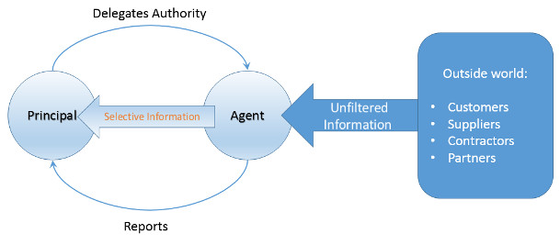

The second broad category of diseconomies of scale includes problems with communication, coordination, and standardization. Overall, I tend to refer to these problems collectively as the Dinosaur Problem. The organization in question has the same issues that the Jurassic behemoths had. Small organizations can comfortably handle peer-to-peer interactions since the number of people involved is relatively small. Once the size exceeds a critical threshold it is more efficient for interactions to happen through a central location, a manager who facilitates the activities of a whole. As the numbers continue to grow more managers come on board and the interaction between them may be handle by peer-to-peer even though the employee interactions are not. At some point, however, the number of managers becomes too large and a new layer of management is conceived and implemented. This layering continues until some point where the right-hand no longer knows what the left hand is doing.

Along the way, such a firm begins to exhibit all the tell-tale signs of being too large. The implementation of a one-size-fits all strategy to avoid liabilities. Having meetings about how to have meetings or for the sake of having meetings. And an emphasis on fairness rather than performance.

<iframe width="560" height="315" src="https://www.youtube.com/embed/kKceJUcZ67Y" frameborder="0" allowfullscreen></iframe>

I’ve lived through all these types of insanities. One of the firms where I worked had a supply requisition form on which one could order refills for X-Acto knives (this was for the actual paper-and-glue version of cutting and pasting) but not the knives themselves. I was issued a corporate American Express card with the very explicit admonition to only use it for business travel and not for personal use. A scant 6 years later I received a letter from legal saying that they were going to revoke my American Express card because I had failed to live up to the expected use of the card. All told, I had never wanted the card in the first place and I was sent on only two business trips in those 6 years. I’ve been required to attend a meeting about how to have meetings.

All of this factors contribute to limiting the practical size of a firm. In the economic lingo, [the economies and diseconomies of scale](http://en.wikipedia.org/wiki/Diseconomies_of_scale) are best summarized on an average cost diagram.

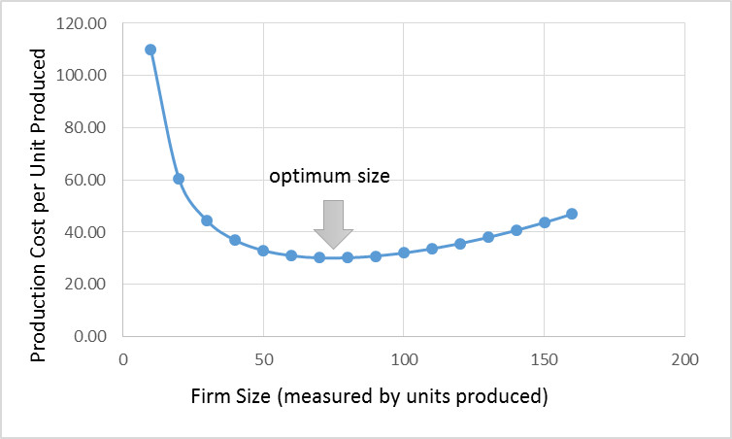

On the x-axis is the number of units of some good or service produced by the firm, which is taken as a measure of the firm’s size. On the y-axis is the cost to produce a unit of the good. The optimum occurs at the place where the benefits from the economies of scale balance the diseconomies. It is important to note that as business factors change, what once contributed to a cost savings can turn around and cause an increase in cost.

So it isn’t remarkable that the small business Davids can take down the big business Goliaths. It also isn’t remarkable that today’s Goliaths were yesterday’s Davids and tomorrow’s has-beens. That is the nature of the creative destruction of the free market economy. It also isn’t remarkable that economies of scale one day can become diseconomies of scale on another as society evolves. What is remarkable is how many people refuse to accept this dynamic.

# Who’s Risk is it Anyway?

I suppose that the subject matter for this particular column started with the arrival of a magazine in my mail box a few days ago. The magazine in question is entitled [‘Arthritis Today’](http://www.arthritistoday.com-sub.info/Arthritis-Today/Welcome) and its presence alongside the more normal mail was a real puzzle. My first reaction was that this was the typical mix up where my neighbor’s mail makes it into my box and vice versa. A glance at the mailing label dashed that notion; the name and address clearly indicated that it was intended for a member of my family.

At bit more of reflection soon led to the answer. One of my clan had been having problems with his hand and had gone to see a doctor. The diagnosis was mild osteoarthritis and a generic treatment program – indicative of the whole ‘we don’t quite know how to treat this so we’ll say something you could have figured out for yourself’ attitude that sometimes is seen in the medical profession – was prescribed.

I’m sure our insurance company was promptly billed and less than two scant weeks later, this magazine arrives unbidden. So the questions of who sent it, when was that particular decision made, how did the publisher know where to send it, and why was it thought relevant seemed plausibly answered. There was only one lingering line of questions.

Who pays for this magazine? Is it a marketing technique, where one issue is sent in hopes that a permanent subscription will result? While possible, this idea seems highly doubtful. There were no indications that the publisher was tempting our dollars from our wallet. No gaudy disclaimers like “fabulous first free issue” or “trial offer” adorned the front of the mailer. This issue of Arthritis Today was sent in the standard clear, thin, plastic bag used for existing subscriptions, which is designed to let you see the content while keeping the pages relatively safe from the elements.

The most plausible explanation is that somewhere between money leaving my paycheck to pay for the family’s health coverage and revenue flowing into the publisher’s offices to pay for staff salaries, print costs, marketing, distribution, and the like, there is a complicated shell game that goes on that makes acceptable the risk of sending out the magazine unsolicited to a perhaps disinterested household.

Several possible explanations exist for how that risk can be perceived as low even if the reality is quite different. Perhaps the doctor’s office pays for the subscription as part of the service they provide. Perhaps the drug companies with a vested interest in pushing the next big arthritis drug underwrite the cost. This later explanation seems to be the most likely as there was a 20-page pamphlet entitled ‘Arthritis Today: Drug Guide, 2015’ that piggybacked along with the main publication.

Most likely this last inference is the correct one. But even if the drug companies are directly underwriting the cost of this publication all that has done is to move the risk associated from one entity (the publisher) to another (the pharmaceutical companies), it doesn’t eliminate it.

We could keep on this way, peeling layer after layer from the onion, but in the end, after all the dust settles and the smoke clears, we still have the undeniable facts that someone is bearing the cost to produce this magazine and the risk that he may not make a return on the investment.

Of course, taking risk and passing on costs is par for the course for businesses. Almost every business must shoulder risk in order to grow and must bear a cost associated with that risk. The cost usually has two components; the first is associated with mitigating the risk and the second is associated with how large will the payout be if the risk realizes. Ultimately some or all of these costs gets passed on to its customers. The amount of risk taking is held in check by the fact that the customer based may finally have enough and move on to a competitor. People are willing to bear a cost when it is a mild irritant or when it looks like it will be limited in time. But push the customer base too far with large or open-ended price hikes and there is an excellent chance that they will leave to find greener pastures, leaving the firm to bear the costs themselves. Competition acts as the natural balance to risk taking.

What is different in the ‘Arthritis Today’ situation, is that there is no danger that the risk and associated costs will be born directly by the company – no matter which one in the chain from publisher, to doctor, to pharmaceutical company. Each of them are in a position to take more risk and pass on more cost than a normal business because of the government mandates and regulations regarding health care. All of the businesses in this chain know that the customer base is a captive audience; that there is no real way for them to move onto a competitor.

This situation is then a textbook example of what is known as a moral hazard. When a moral hazard is present, a firm can and will take a greater risk when they know that some other party will be stuck with the cost. In this case, the particular cost is born by my health care coverage provider who will then pass the pain directly onto me in the form of higher premiums, larger deductibles, or both.

Overall, the cost of receiving this magazine is small but it is worrisome for two reasons. The first is the basic principle that I shouldn’t have to bear a cost as a captive customer base. The second is that this case is a symptom of an endemic problem throughout the economy. Many of the government-backed, ‘too big to fail’ or ‘special interest’ programs show the same type of moral hazards on a much grander scale. I’ll be exploring some of the more egregious ones in future columns.

# Bookies & How to Set Odds

In honor of American Pharoah winning the first Triple Crown in 37 years, this week’s column will concern itself with that fine art of subtle economics – making book. For those you aren’t familiar with the terminology, to make book is the phrasing used to describe how a bookie balances the risks associated with backing a gambling opportunity. The idea behind making book is to guarantee a positive expected income for the bookie no matter what happens in the event.

The treatment here is patterned after ‘The Parable of the Bookmaker’ found in the book ‘Financial Calculus: an introduction to derivative pricing’, by Baxter and Rennie and the very readable discussion of [‘The Art of Bookmaking’](https://betting.betfair.com/the-art-of-bookmaking.html) Matt Elliott.

Both treatments consider, for simplicity, the case with a sporting event with two possible outcomes. I’ll stick with the horse racing theme used by Baxter and Rennie.

Suppose that we are having a runoff between the great Triple Crown winners of yesteryear and American Pharoah. I think that, without a doubt, Secretariat is the greatest of the past winners; [an opinion that is shared in sporting circles](http://www.latimes.com/sports/sportsnow/la-sp-sn-ranking-the-triple-crown-winners-20150605-story.html). Now let’s imagine that we are pitting Secretariat against American Pharoah as our sporting event of the millennium.

As bookies, we want to accept wagers from bettors who are both favor Secretariat and those who favor American Pharoah, but we want to do so in such a way that regardless which horse actually wins, we can meet our payouts and still take home a tidy profit. How do we do this?

First, let’s start by examining the probability that each horse will win the race. Since this is a fantasy race, we can run the race as often as we like, and suppose that in doing so we find that Secretariat is 3 times more likely to win than American Pharoah.

Now we have to set the odds. The actual language and notation associated with quoting the odds seems to differ from country to country and culture to culture so I am going to give a set of definitions that maximize the overlap with all cases. First define the ***stake*** as the amount of money that the bettor (or punter as it is sometimes known as) places on the outcome. A winning bet pays the bettor back his original stake plus an additional amount of money called the ***return***, since it represents the return on his investment. Thus the successful bettor walks away from the track with the sum of these two, which is called the ***payout***. In symbols, if ***st*** is the stake and ***r*** is the return then ***p = s + r*** is the payout. The unsuccessful bettor simply walks away.

Now if we set our odds consistent with the probabilities found in our fantasy running, we would set the odds as follows:

* Secretariat: a stake of 3 gives a return of 1 for a payout of 4
* American Pharoah: a stake of 1 gives a return of 3 for a payout of 4

In other words, the probability each outcome is implied as the stake/payout giving P(Secretariat) = 0.75 and P(American Pharoah) = 0.25, where P(x) is the probability that x will win the race. Note that as expected, Secretariat is three times as likely to win as is American Pharoah.

Well this is certainly the scientific way to set the odds. Unfortunately, it is also stupid. To see this, we calculate the expected payout. To keep things concise, let’s use add to our symbol vocabulary by letting AP and S stand for American Pharoah and Secretariat, respectively. In the event that Secretariat wins, the profit the bookie makes as follows: he gets to keep the stake offered for American Pharoah and has to give up the return on Secretariat. In symbols, **profit(S)** = **st(AP)** – **r(S)**. In the event that American Pharoah pulls off the upset, the bookie’s profit is the stake on Secretariat minus the return on American Pharoah, which in symbols is **profit(AP)** = **st(S)** – **r(AP)**. To get the expected profit, the bookie multiplies the profits associated with these two events by their probability of occurrence and finds that his expected profit is zero (left as an exercise to the reader). This result holds no matter how much money is staked on either horse, since there are only two options – they balance out.

So a bookie offering such odds works for free in the long run and finds himself at the end of his career having, on average, earned no money. More likely, before he gets to the point of having a quiet retirement he finds that he is bankrupt due to the fact that on any given occasion he is liable to lose a huge amount of money.

The amount he is liable for does depend on the stakes offered and the easiest way to understand this is to look at a table of outcomes given different stakes.

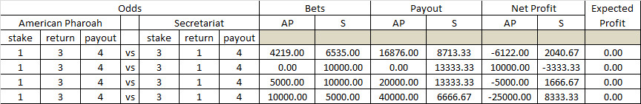

Notice that there are four different scenarios with different amounts places as bets on the two horses. In all cases, the bookies expected profit is zero so that were the race to be run every day, the bookie would, as predicted above, break even. However, during that time the bookie’s profits would wildly fluctuate between a reasonably handsome profit of $10,000 when American Pharoah pulls of the upset and nobody bet on him to a disastrous loss of $25k when many people back the longshot and he wins.

Obviously, the bookie needs to keep his financial health (and as a result his physical health as well). In order to do that, he needs to ‘slant’ the odds in his favor. He does this by actually playing with the percentages sold of the racing contracts so that he has a positive profit no matter which horse wins.

Several examples of how to set the odds to make a profit are shown in this next table.

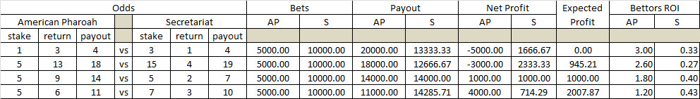

Before beginning to discuss the results shown in this table, note that the amount bet on the two horses is fixed at $5K for American Pharoah and $10K for Secretariat. I’ll briefly discuss the added complexity associated with attracting the appropriate amounts for both horses below.

The first case is the fair-odds, break-even case that caused our bookie’s concern. In that case, the implied percentage of the race came out exactly to 100 percent. This percentage, denoted by **o**, is given by **o** = **st**/**p**. For the first case, **o(AP)** = 0.25 and **o(S)** = 0.75; adding up to 1.0, as expected. In the other cases, the bookie sets the odds in such a fashion that the corresponding percentages add up to be more than 1.0. In the second case **o(AP)** = 5/18 = 0.28 and **o(S)** = 15/19 = 0.79 for a sum total of 1.07. This extra 7-percent margin give the bookie a positive expected profit but still exposes him to substantial loss if the longshot come in.

A better setting of odds is in the third case, where **o(AP)** = 5/14 = 0.36 and **o(S)** = 5/7 = 0.71. Again the margin is set at 7 percent (0.36+0.71 = 1.07), but in this case the bookie is sure to make a profit of $1,000 every time.

In the final case, the bookie can make even more profit by having a margin of 15 percent, but he does so at the expense of the bettor (how else?). In particular, the bookie realizes this profit by cutting into the return on investment of the bettor who backs the longshot. The return on investment (ROI) is defined as the return divided by the stake, or **r**/**st**. Notice how the ROI drops progressively as the bookie’s exposure to risk drops.

In realistic situations, the bookie never gets a fixed amount plopped on each horse with the subsequent opportunity to set the odds in such a way that favors him. Rather, he needs to sell contracts with the bettors and then adjust the odds as bets come in so that he makes book. More details of how this is done can be found in [Matt Elliott’s discussion](https://betting.betfair.com/the-art-of-bookmaking.html) but I’ll note, in passing, that a margin of 7-percent seems to be a customary target but that it seems that the bookie is happy when he can achieve 5 percent.

I’ll close with one last point. Throughout this discussion, I’ve intermixed gambling terms like bookie, odds, payout, and longshot, with terms usually reserved for business situations, like return on investment, contract, and sell. Gambling and business meet squarely in derivatives trading and hedge funds all across the financial markets.

# Too Many T’s

One of the hot-button items in the current news cycle is the ‘stinging defeat’ that the Obama administration suffered at the hands of Congress last week. This defeat took the form of an overwhelming rejection of certain trade provisions that were proposed by the administration be made law.

I am not interested in taking up space in this column to discuss the merits and demerits of the laws themselves. Even though trade certainly falls under within scope of a blog of ‘musings about time and money’, I haven’t invested the time to really form an intelligent opinion about the proposed powers that the president was seeking.

No, what I want to comment on is the lack of clarity in the terminology associated with these laws. This lack of clarity was abundantly clear to me as I struggled to keep TPP straight from TPA from TAA. There were simply too many T’s to keep straight without careful thought and confusion was sure to abound.

Sadly, it seems that even trained journalists (I often wonder if that term is an oxymoron – but I digress) seem incapable of discerning the difference. A point that was driven home as I listened to NPR’s Steve Inskeep as he clumsily interviewed Paul Ryan about these matters.

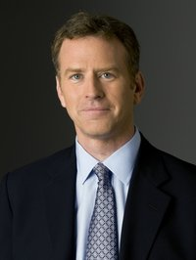

NPR’s bio has the following to say about Mr. Inskeep

Known for probing questions to everyone from presidents to warlords to musicians, Inskeep has a passion for stories of the less famous—like an American soldier who lost both feet in Afghanistan, or an Ethiopian woman's extraordinary journey to the United States.

Despite his probing intellect and passion and compassion for his fellow man, Steve is apparently unable to keep his alphabet soup straight, so as a public service in the opposite direction of the usual, I present some basic information about the three T’s back to NPR.

## The TPP

The [Trans-Pacific Partnership (TPP)](https://ustr.gov/tpp/outlines-of-TPP) is [a proposed trading framework](https://ustr.gov/tpp/outlines-of-TPP) between the United States of America and eight other Trans-Pacific countries – Australia, Brunei, Chile, Malaysia, New Zealand, Peru, Singapore, Vietnam.

The TPP is essentially a larger, and perhaps more ambitious, version of such free trade arrangements as [NAFTA](https://en.wikipedia.org/wiki/North_American_Free_Trade_Agreement) or the [Israel Free Trade Agreement](https://ustr.gov/trade-agreements/free-trade-agreements/israel-fta). The United States has entered into many such agreements (14 by my count). Its advocates tout its promise of open markets in Asia, level playing fields when it comes to such things as intellectual property rights and import/exports, and to the influence the US will have in improving working conditions. Its opponents point to infringement on US sovereignty, the jobless and rather dismal recovery, and the threat of displaced workers, which brings us to item two – the TAA.

## The TAA

The [Trade Adjustment Assistance (TAA)](https://en.wikipedia.org/wiki/Trade_Adjustment_Assistance), is a federal program (or maybe more appropriately a set of programs) designed to help certain segments of the economy that are damaged by the opening of new markets, either domestic or abroad, to new competition.

The largest function of the TAA is to provide assistance to displaced workers who find themselves either out of a job or threatened with weakening wages and bargaining power due to an increase in the labor pool.

A familiar situation in which TAA-like service may have been applied was during the transition from typewriters to word processing programs for the desktop computing (although the TAA doesn’t cover workers [displaced by technology or changing tastes](http://americastradepolicy.com/trade-adjustment-assistance-wasteful-program-or-moral-obligation/#.VYN7m_lVhBc)). This relatively sudden change in technology and office process forced almost all employees in the typewriter manufacturing sector out of work. These workers could have received help from the TAA to train new jobs in different sectors (if the TAA had actually been able to help).

Proponents of the TAA point to the continuity it brings to the lives of workers as they transition into new careers: minimizing impact to them and their families and keeping them in the work force. Most sides agree that the objectives of the TAA are sound, but some point to the [particular implementation as being flawed](http://www.heritage.org/research/lecture/trade-adjustment-assistance-a-flawed-program).

## The TPA

The final T in the trinity (yet another T-word) is the [Trade Promotion Authority (TPA)](https://en.wikipedia.org/wiki/Fast_track_(trade)). Also known as Fast Track, the TPA is a power granted by Congress to the President to act as a single negotiator for the United States. With this power comes great responsibility, so when a deal had been tentatively struck, the President must then bring the completed deal back to Congress where it is subjected to a single up-or-down vote, with no opportunity for amendments.

The TPA is very controversial, primarily due to the concentration of power to negotiate potentially disruptive trade deals in the hands of a small number of bureaucrats. Those in favor of granting the president TPA argue that no foreign country wants to negotiate with 536 people (all of Congress and the president) and the fact that Congress has the last word. TPA opponents insist that closed-room negotiations that impact thousands or millions of workers is un-American and that it places too much power in the hands of people who might be corrupted by it (see Lord Acton’s famous maxim).

## Summary

Despite the similarity in their acronyms, the three Ts taking center stage in this current trade debate are really distinct things of varying controversy. The least objectionable is the Trade Adjustment Assistance (TAA), which seems to have universal support for what it tries to do even if opinions disagree on how to do it or how efficacious the current implementation is. The next two Ts are close in their controversy level, but I think that the Trans-Pacific Partnership (TPP) runs in second. Sides are divided on whether they like what this deal brings to the table but not as much as they seem to be in disagreement on how it will happen. Granting the president Trade Promotion Authority (TPA) seems to be a real sticking point and if he doesn’t get this authority the next logical question is how will the US negotiate free trade agreements (maybe there is even debate as to whether it should, but that is a topic for another blog).

So it’s easy to see that the 3 Ts are quite different and that with a little work, even a journalist should be able to keep them straight.

# Save the Economy, Nuke a City

Yes, dear reader, the title of this article is not a misprint. I am advocating that we take one US city and level it. Think of all the economic activity that will result as the country bends its time and resources to rebuilding the city.

Now, to be sure, I don’t mean that we do this unannounced and without warning. There could be a national lottery wherein one city, chosen at random, would be slated for total demolition. The citizens would be given ample time to pack up their belongings, family pets, and the like. Spaces for them in nearby cities and suburbs would be secured where these lucky ones wait until there new homes are ready. Once the city was cleared, a bomber could fly overhead and drop a small nuclear weapon onto the heart of the downtown district.

Once the heat and radioactivity have faded, tens or hundreds of thousands and workers, who had spent the intervening time studying under government sponsored job-retraining programs, can swoop in, clear out the remains, and rebuild the city. In relatively short order, the residents could return to a brand new, shiny community ready for action.

Note the abundance of economic activity this city-revitalization would spur; how numerous industries would see an influx of revenue. Local transportation and rental housing (homes, hotels, motels, campgrounds, or whatever) would see a spike in demand during the outflow of the population prior to the extreme makeover. The military-industrial complex would also get a piece of the action since they would be responsible for the bombing run, which would keep munitions manufacturers and aerospace corporations profitable. Of course, the greatest win-fall goes to the construction and materials companies whose job it is to rebuild the new and gleaming metropolis.

Hmmm…..

Sounds ridiculous doesn’t it. Who in their right mind would ever advocate wanton destruction just for the flurry of activity that would result?

Take a peek at some of the places where this idea rears its ugly head.

In our first example in the circus of the economic bizarre, consider, if you will, the possibility of space aliens attacking the planet as a rallying cry for economic production

<iframe width="560" height="315" src="https://www.youtube.com/embed/jaED2ErdIv8" frameborder="0" allowfullscreen></iframe>

In this space alien piece, from 17 to 30 seconds, the ‘host’ of the show literally says:

Wouldn’t John Maynard Keynes say that if you employ people to dig a ditch and then fill it up again, ah, that’s fine, they’ve been productively employed…

How strange of a definition he presents for ‘productively employed’. How is digging a ditch only to fill it up again productive? Makes the ‘nuke a city plan’ sound positively brilliant.

Our second offering in our gallery is more whimsical.

<iframe width="420" height="315" src="https://www.youtube.com/embed/SnzzWGcdMqY" frameborder="0" allowfullscreen></iframe>

Taken from the movie ‘The Fifth Element’, this scene mocks the idea that destruction ultimately leads to progress. But an idea has to exist in the first place to actually be mocked and this particular idea seems to have been around for quite some time.

Perhaps the best argument against this kind of thinking comes in [‘The Broken Window’ parable](http://bastiat.org/en/twisatwins.html#broken_window) written by Frederic Bastiat in 1850. In this short essay, Bastiat examines the unseen costs (lost opportunity costs) of having a perfect fine window broken and the vapid thinking that says that that destruction is beneficial to society.

Of course, a little destruction may be beneficial when it removes at valueless or costly thing out of the way of a new thing that actually brings value to society but that we need to be very sure that the thing being replaced is valueless. As the Henry Hazlitt says in his book ‘Economics in one lesson’

"It is never an advantage to have one’s plants destroyed by shells or bombs unless those plants have already become valueless or acquired a negative value by depreciation and obsolescence. ... Plants and equipment cannot be replaced by an individual (or a socialist government) unless he or it has acquired or can acquire the savings, the capital accumulation, to make the replacement. But war destroys accumulated capital. ... Complications should not divert us from recognizing the basic truth that the wanton destruction of anything of real value is always a net loss, a misfortune, or a disaster, and whatever the offsetting considerations in a particular instance, can never be, on net balance, a boon or a blessing."

It seems to me that that key phrase ‘unless those items [sic] have already become valueless or acquired a negative value by depreciation and obsolescence’ is conveniently omitted from the regular dialog.

Trained economists, no doubt, know and understand this subtlety, but if they do they like to keep it to themselves. The average level of discourse in the media is well typified by the two clips above. It seems to me that we should be very cautious in concluding that an object is truly valueless and that destruction is the correct course of action. I’m not saying that such a conclusion should be rare but rather that it should always be highly scrutinized. When we get to the point of saying that it would be better to have people dig ditches just to fill them back up then we’ve run out of good ideas. And when we’ve run out of good idead, nuking an entire city starts to look a lot more attractive.

# To GMO or Not to GMO

There has been a lot of recent buzz centering on the fear that certain segments of the population have about genetically modified organisms or GMOs. These apprehensions are a part of an ever-growing concern that people around the world have in the way that their food is produced and how healthful said food might be. Concerns over GMOs rank up there with the movement to have free range livestock and organically grown foods. So what does all this biological science have to do with a blog on economics you might ask. Well, simply put, everything.

At its core, economics is the study what goods and services society produces where, when, and how; who produces it; and who consumes it. Sometimes, it even ventures a guess as to why but that question is broached far less often than at first it may appear. Since the production of goods and services happen in the faces of finite resources and perpetual scarcity there is always a downside to every decision. If resources are being spent one way they are not being spent on something else.

So of course, the decision to embrace GMOs fully, partially, or not at all is, at its core, a decision about how resources will be spent to satisfy on of the most basic human needs – the need to eat.

Identifying the particular risks of using GMOs is the province of a host of people, including the biologist, the botanist, the farmer, the food distributor, the politician, and so on. Once the risks have been listed, the weighing of these risks is purely economics and is the province of us all.

However, it is hard to properly weigh the risks when a twofold set of errors is in play as it seems to be now. The first error is one of emotional rather than rational thinking. The second is the lack of vision is seeing the lost opportunity or unseen costs of choosing one over the other.

I mention these errors because there is mounting evidence that the developed countries are so mired in a dread of the GMO-monster that they are consigning millions of people in the developing world to avoidable chronic hunger, malnutrition, or death.

## Emotional Thinking

The first of these errors, the indulgence in emotional thinking, seems to be gaining ground in many of the modern debates. Within the past decade, there has been a rise in trendy, boutique causes where the passion is profound but the logic is scarce. A familiar example is the movement in certain circles to avoid vaccinating a child due to the fear that the vaccinations cause autism. There isn’t strong evidence to support this conclusion but that doesn’t stop certain people from [engaging in emotional attacks against those who honestly disagree with this conclusion](http://www.latimes.com/local/lanow/la-me-ln-actor-jim-carrey-vaccines-20150701-story.html).

Advertisers and marketers are eager to fan the flames of emotionalism if it helps sell a product and one such case is the recent switch by [Chipotle to ‘non-GMO ingredients’](http://www.businessinsider.com/chipotles-gmo-ban-criticisms-2015-5). Chipotle’s website presents a slick picture

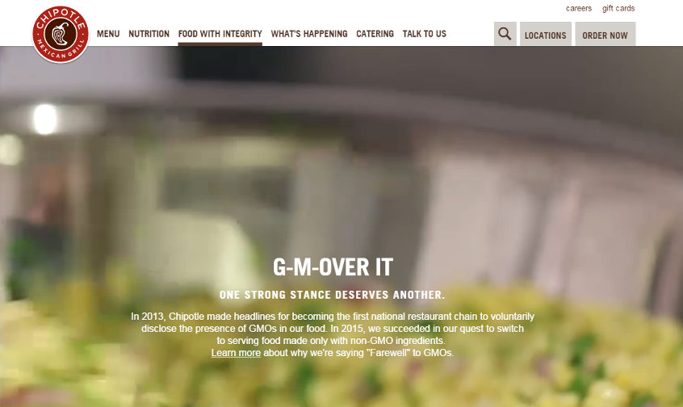

with catchy little lead-in phrase (G-M-Over It) and a short paragraph extoling the companies conscientious “Farewell” to GMOs. Following the ‘Learn More’ link leads to an equally emotion-filled excerpt:

Chipotle is on a never-ending journey to source the highest quality ingredients we can find. Over the years, as we have learned more about GMOs, we’ve decided that using them in our food doesn’t align with that vision. Chipotle was the first national restaurant company to disclose the GMO ingredients in our food, and now we are the first to cook only with non-GMO ingredients.

But if the reader were to persist in reviewing the reasons why Chipotle is saying “Farewell” to GMOs that reader would find a lot of far less emotionally-laden and circumspect words. Buried in the ‘fine print’, are phrases like “we don’t believe the scientific community has reached a consensus” and “we believe it is prudent to take a cautious approach to GMOs”. Even further in, Chipotle admits that while it is now shunning GMO plants, it has not eliminated GMOs from its supply chain.

But it is important to note that most animal feed in the U.S. is genetically modified, which means that the meat and dairy served at Chipotle are likely to come from animals given at least some GMO feed – Chipotle website

So how much of a “Farewell” can they have made? It seem more likely that this new campaign to eliminate GMOs (or appear to be doing so) is not designed to protect customers from their dangers as much as it is to boost the flagging stock price of company, which has been on a downward trend since February of this year.

## Lost Opportunities to Eat

If this emotionalism were simply fueling an advertising campaign to separate consumers from their money, then one might argue that this it is a victimless crime with no real repercussions. But in world with limited resources, there are significant lost opportunity costs.

One unseen cost is that the use of land, livestock, and crop resources at less than peak efficiency means that less food is being produced than otherwise would be. That would be okay if there were plenty of food – that is to say the supply of food matched the demand. In that case, there would be no incentive to raise production and no pressure for prices to rise. Such is the [long term trend in the US](.%20%20In%20the%20.) (although food prices have been rising recently and it may be that the bottom has been reached) but is not the case in the developing world.

The Genetic Literacy Project recently published an article by Michael Dzakovich that points out fears over GMOs have prevented their use in Africa.

|  |
| --- |
| While many farmers in industrialized countries have been safely and successfully using genetically engineered crops for almost two decades, adoption in the developing world has been significantly slower, only recently eclipsing the U.S. in terms of total acreage. [Michael Dzakovich](http://www.geneticliteracyproject.org/author/michael-dzakovich/) |

Mr Dzakovich provides a vivid picture of the unseen costs of slow adoption of GMOs when he writes

At dinner during the conference, a discussion about the debate over genetically GM crops within the United States turned to the situation in Africa, when Erostus Nsubuga, a Ugandan conference delegate, said “People are dying of hunger in Uganda. We are willing to use any technology.”

It was a startling statement and wake up call, challenging our complacency. As Americans continue to quibble about phantom fears related to genetically modified crops, 20,000 people—more than six World Trade Center disasters—die every single day from malnutrition, at least some of whom would be saved if GM crops were legalized.

Other articles on the Genetic Literacy site suggest that GMOs may help [reduce carbon emissions](http://www.geneticliteracyproject.org/2015/04/29/are-gmos-increasing-profits-of-farmers-and-biotech-companies-at-environments-expense/) and [lower toxic pesticide use](http://www.geneticliteracyproject.org/2015/05/07/gmo-free-myth-busting-labeling-movement-leading-farmers-to-use-more-toxic-chemicals/).

Clearly there are pros and cons in adopting wide-spread use of GMOs and the risks and the benefits need to be carefully considered. But emotional arguments and slick advertising campaigns only serve to further hide and obscure the lost opportunity costs and people may be unnecessarily dying as a result.

# Value and Trade

I suppose the origin of this particular column came from a rather comical conversation held over dinner. My wife mentioned that her father used to tease a cook he knew about her efforts in the kitchen. Her father contended that cook’s efforts were proof that Marxism was wrong about the value of a thing made in the economy. According to Marxism, the [value of any object is determined by the total amount of labor required to make it](https://en.wikipedia.org/wiki/Labor_theory_of_value).

The cook would select a great recipe for the main course, would purchase the finest ingredients, and would labor long and diligently over the preparation. Of course, the meal would often be a great disappointment and, sometimes nearly inedible. Any restaurant serving such a dish would soon go out of business.

The inverse situation also occurs. There seems to be many instances were by accident, an entrepreneur just happens to ‘catch lightning in a bottle’. A simple idea brought to market with minimal effort makes a fortune for its owner. If you are thinking about the pet rock then you are reading my mind.

A very comic example of this latter situation occurs in the original movie version of the Producers, where Max Bialystock moans:

[“How could this happen? I was so careful. I picked the wrong play, the wrong director, the wrong cast… where did I go right?”](https://www.youtube.com/watch?v=E8JVrlLQucc&feature=youtu.be&t=1h29m35s)

So what to make of this Marxist idea? How much truth is there in the idea that if it took twice the amount of effort to grow one type of crop, say a bushel of wheat, as it did to grow another, say a bushel of corn, then the bushel of wheat holds twice the value as the bushel of corn.

Oddly enough the idea originated well before Marx, with roots being traced back to the philosophical works of the Middle Ages. Thomas Aquinas is [credited for noting in his Summa Theologica](https://en.wikipedia.org/wiki/Labor_theory_of_value#Origins_of_the_labor_theory_of_value) that

"... value can, does and should increase in relation to the amount of labor which has been expended in the improvement of commodities."

This concept also shows up in the classical school of economics. It was touched on by Adam Smith in his *Wealth of Nations* but it doesn’t seem that Smith actually embraced the idea as being applicable for anything more than the most primitive of societies (or rude societies as he put it).

Other classical economists, for example Ricardo, held more broadly to this concept making it part of their structure for economics. Although even then, there were doubts about the universality of this idea. The labor theory of value was embraced by Marx as an important and operative principle but it seems clear that the notion, with no additional provisos, is untenable. The notion that the buyer in the transaction has no place in determining the value of the thing being purchased is short-sighted and laughable.

Perhaps the best illustration of how much of value lies in the eyes of the customer is the following passage from Chesterton’s The Queer Feet:

The Vernon Hotel at which The Twelve True Fishermen held their annual dinners was an institution such as can only exist in an oligarchical society which has almost gone mad on good manners. It was that topsy-turvy product--an "exclusive" commercial enterprise. That is, it was a thing which paid not by attracting people, but actually by turning people away. In the heart of a plutocracy tradesmen become cunning enough to be more fastidious than their customers. They positively create difficulties so that their wealthy and weary clients may spend money and diplomacy in overcoming them. If there were a fashionable hotel in London which no man could enter who was under six foot, society would meekly make up parties of six-foot men to dine in it. If there were an expensive restaurant which by a mere caprice of its proprietor was only open on Thursday afternoon, it would be crowded on Thursday afternoon.

If the labor theory of value is not a viable approach for determining value, what is? That is a question that occupies a great deal of economic discussion even until today and there is no universally held belief. Mainstream economists do lean toward the idea that free trade best uncovers the value of a good or service because in the free market the value of the thing will be determined best by the currency that will be offered to purchase it.

As a result, [trade is actually seen as the mechanism by which value is created or imparted to a good or service](http://webnt.calhoun.edu/distance/internet/Business/eco231/downloads/lnc2prime.pdf). Free trading allows for the assessment of value by letting lots of people ‘vote’ on the value. To paraphrase Churchill, this economic democracy is the worst form of finding value except all the others that have been tried.

Please pass me the pet rock.

While

This approach

A short and sweet summary of the modern position is put forth in the [brief article on trade from economicthinking.org](http://www.economicthinking.org/everydebater/every5.html):

In short, every policy that restricts free trade, free contract, or free entry into the market diminishes wealth for individuals and the nation as a whole.

Economic schools of thought

General references:

http://www.pragcap.com/a-cheat-sheet-for-understanding-the-different-schools-of-economics

http://www.zerohedge.com/news/2014-06-25/pocket-guide-understanding-different-schools-economics

http://www.zerohedge.com/sites/default/files/images/user3303/imageroot/2014/06/20140625_econ.jpg

|  |  |  |  |  |  |
| --- | --- | --- | --- | --- | --- |
| School of Thought | General Summary | Economic Unit | Personal Freedom | Value & Wealth | References |
| Austrian |  |  |  |  |  |
| Behavioral |  |  |  |  |  |
| Chicago |  |  |  |  |  |
| Classical |  |  |  |  |  |
| Keynesian |  |  |  |  |  |
| Marxism |  |  |  |  |  |
| Neoclassical |  |  |  |  |  |

## Bankers – Friend or Foe?

The 2008 recession added a lot of new phrases to the economic lexicon. Terms like ‘sub-prime mortgages’ and ‘produce the note’ found their way, nearly overnight, into domestic dinner conversations and water-cooler discussions. Perhaps none of the Great Recession taglines garners as much attention and derision as the phrase ‘too big to fail’.

Applied to the banking industry, ‘too big to fail’ spawned a variety of political reactions, from bitter laughter, to contempt, to despair, depending on one’s own personal circumstances.